GRAPHICS DEVICE INTERFACE

The **Graphics Device Interface (GDI)** is a crucial component of Microsoft Windows, responsible for displaying graphics on video displays and printers.

📍 What is GDI?  
The **Graphics Device Interface (GDI)** is a core part of Windows—it’s what your app uses to **draw** things on the screen or **print** stuff on paper. Whether it’s menus, scroll bars, cursors, or icons—**GDI is doing the rendering** behind the scenes.

🎯 Core Purpose of GDI

* Render graphics to **video displays** or **printers.**
* Used by both **user applications** and the **Windows OS itself.**
* Lives in the system library: GDI32.DLL.

🧠 **Think of GDI as a middleman** between your app and the hardware (screen or printer). You tell GDI what to draw, and it figures out how to tell the device.

📜 GDI in History

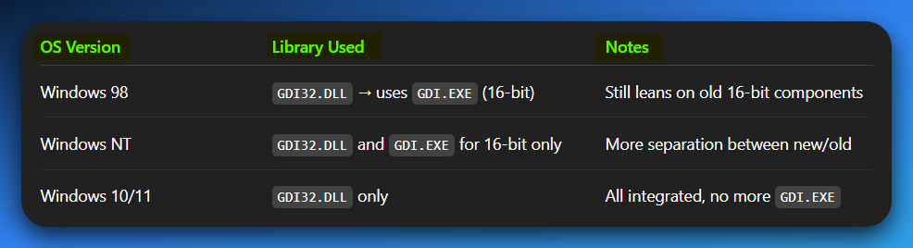

✅ **Modern Note:** You can safely ignore GDI.EXE if you’re targeting anything newer than WinXP. Everything you need is in GDI32.DLL.

✅ **Windows NT** used a separate 16-bit library and GDI.EXE for GDI functions in older 16-bit programs. Now, all that old functionality is part of GDI32.DLL in modern Windows versions like 10 and 11.

🔧 How GDI Works (Under the Hood)

These dynamic-link libraries interact with device drivers for the video display and any connected printers.

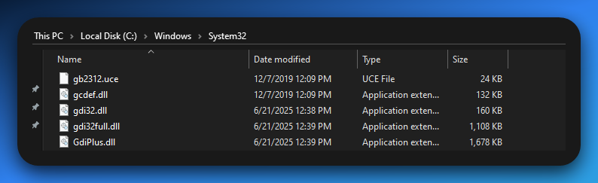

GDI32.DLL acts as an intermediary, sending commands to device drivers.

These drivers then handle the direct communication with specific hardware, like your **screen** (via video drivers) or **printer** (via printer drivers that convert GDI commands into printer-specific instructions).

GDI itself **does not communicate with hardware directly;** it relies on these drivers.

🛠️ Use Cases of GDI

* Drawing basic shapes (lines, rectangles)
* Handling text output
* Displaying images/bitmaps
* Printing documents
* Building UI elements

⚠️ GDI Philosophy TLDR

* You draw using **logical coordinates**
* GDI maps them to **physical devices** (monitor/printer)
* **Device Contexts (DCs)** are how you interact with GDI (coming up next!)
* GDI functions are exported from the dynamic-link library GDI32.DLL.

Device-Independent Graphics

GDI is designed to support **device-independent graphics.** What do we mean by that?

It allows Windows programs to display graphics on **any compatible screen** or **printer** without needing to know the device's specific details.

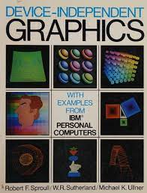

GDI provides tools that **hide the complex details** of different screens or printers from your program.

So, your application **doesn't need to be custom-written** for every single display or printer model; GDI handles that translation.

It means your app can draw something **without knowing or caring** what kind of screen or printer it's being shown on.

**Instead of talking directly to the monitor or printer, your app says:**

* “Yo GDI, draw me a red rectangle here.”

**And GDI’s like:**

* “Bet. I’ll figure out what that means for a 1080p screen, or a dusty HP printer from 2011.”

You don’t write code for every type of display—**GDI does the translating** behind the curtain.

Imagine you're ordering food on Uber Eats.

*You don’t care whether your food is delivered by a bicycle, a car, or a drone with attitude.  
You just tap "Chicken biryani", and Uber (GDI) figures out how it gets to your door.*

*Whether it’s a sweaty biker or a Tesla autopilot, you don’t rewrite your order— Uber adapts to the "device".*

*Same deal with GDI: You say “draw this” → GDI figures out “how” for the target device.*

Raster vs. Vector Devices

Graphics output devices can be categorized into two main types:

* **Raster devices**
* **Vector devices.**

**What exactly is a raster device?** Simply put, it's any piece of hardware that creates images by arranging a rectangular grid of tiny individual dots.

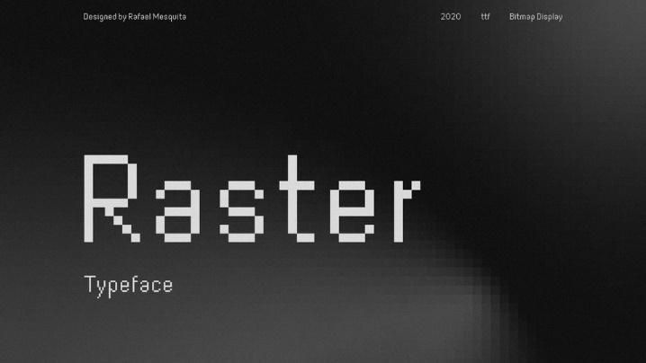

Think of it like building a picture with a massive collection of LEGO bricks.

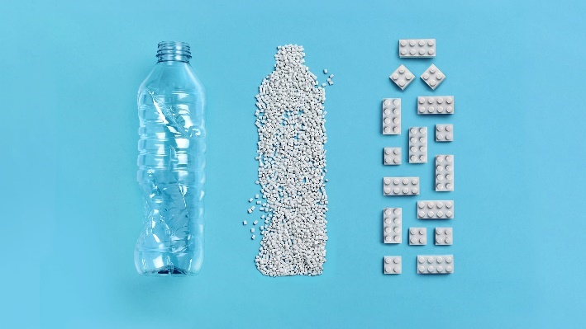

Another example is creating a mosaic tile by tile.

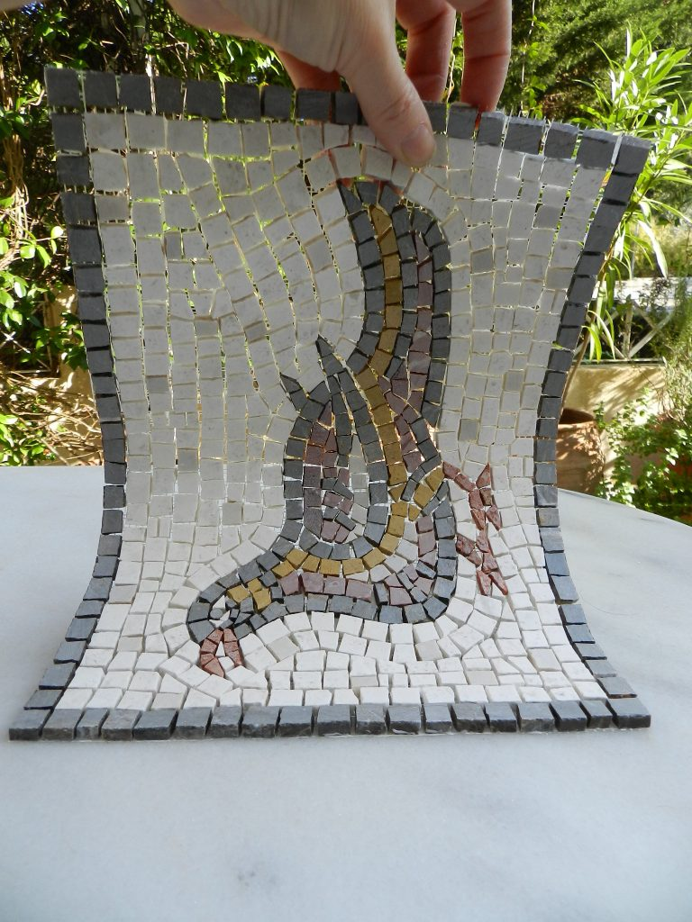

Each one of those tiny dots or "tiles" is called a **pixel** (short for picture element). When you put millions of these pixels together, each with its own specific color, they form the complete image you see.

Here are some common examples of raster devices you encounter every day:

**Computer Monitors (LCD/LED screens):** Every image, text, or video you see on your display is made up of millions of glowing pixels arranged in a grid.

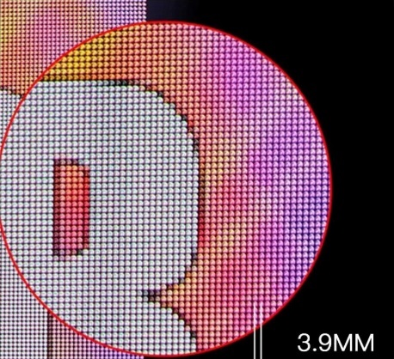

**Laser Printers & Inkjet Printers:** When these printers put ink or toner onto paper, they do so by placing tiny dots very precisely, forming the image or text.

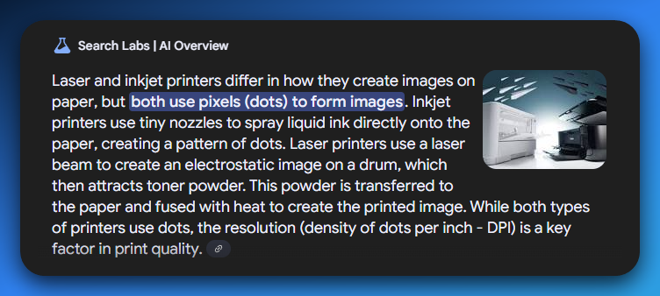

**Dot-Matrix Printers:** These older printers literally use tiny pins to strike an inked ribbon, creating a pattern of dots on the paper.

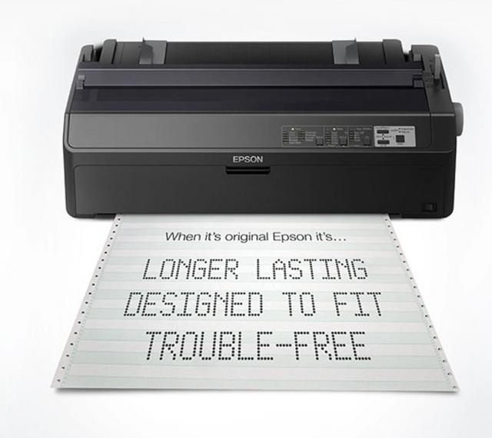

**Scanners:** When you scan a document or photo, the scanner is essentially taking a picture by reading the individual pixel (dot) information from the original, turning it into a digital grid.

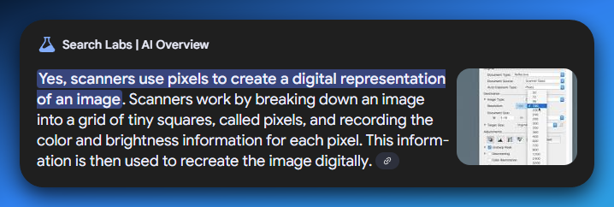

The key takeaway is that GDI (Graphics Device Interface) interacts with these devices by telling them **which pixel should be what color** in their grid to draw the desired image.

**GDI doesn't draw directly;** it translates your app’s drawing commands into instructions that these pixel-based devices can understand.

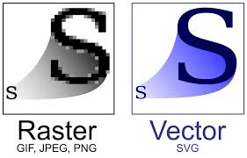

📏 Vector Devices = Math & Lines

Unlike raster devices that draw with tiny dots (pixels), **vector devices** create images using mathematical instructions. Instead of a grid of colors, they use formulas to define shapes like lines, curves, and points.

Think of it like **giving a robot precise instructions**:

* *"Draw a perfectly straight line from point A to point B," or*
* *"Draw a perfect circle with this center and radius."*

Because these drawings are based on mathematical equations, they have a huge advantage: **you can scale them to any size** without ever losing quality.

Whether you make a vector line tiny or blow it up to **billboard** size, it will always remain perfectly sharp and smooth, **never blurry** or **"pixelated."**

This **precision** is why vector graphics are crucial for things that need exact cuts or highly detailed scaling.

1. Plotters (those robotic pen machines): These are robotic drawing machines that use pens to physically draw precise lines on large sheets of paper, often used for architectural blueprints or engineering diagrams.

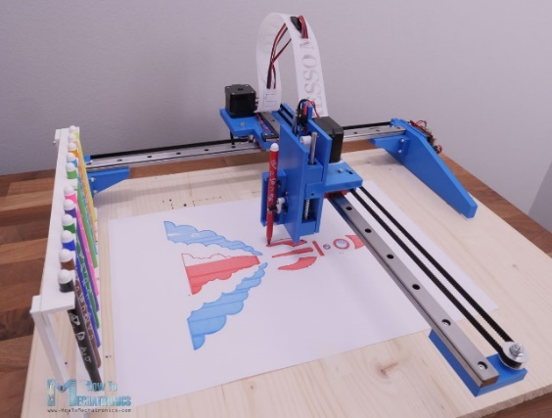

2. Laser Cutters or Engravers:Many of these machines use vector data to guide a laser beam to cut or etch materials with extreme accuracy, following the exact mathematical paths defined in the design.

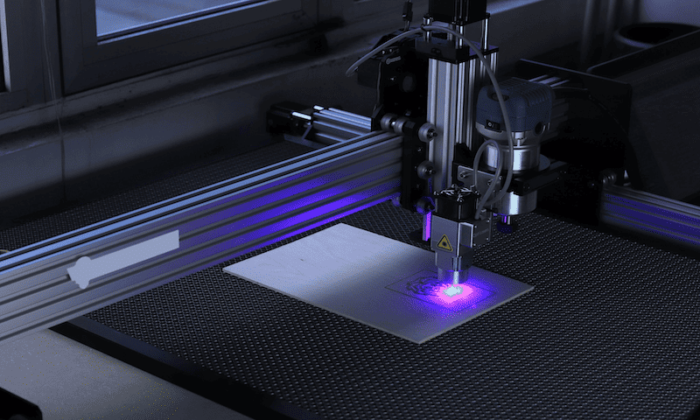

3. Old-School Drafting Hardware:Before computers, these were the mechanical drawing tools and machines that enabled engineers and architects to create incredibly precise drawings based on mathematical principles.

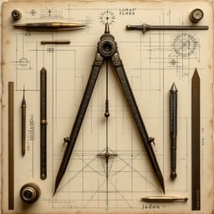

GDI AS A HIGH-LEVEL INTERFACE

🖥️ GDI as a High-Level Interface: The "C of Graphics Programming"

When you're working with graphics on a computer, you're dealing with one of two styles: **vector-based drawing** (like shapes, lines, and curves) or **pixel-based manipulation** (the nitty-gritty dots on the screen).

Traditional graphics programming often leans on **vectors**, keeping your code abstracted from the hardware.

You're not directly telling the monitor, **"Hey, light up pixel (24, 36) in blue"** — instead, you might say **"draw a rectangle,"** and let the system handle the pixel-level work.



This is where the Windows GDI (Graphics Device Interface) comes in. GDI is a beast of two faces:

* *It lets you draw high-level vector graphics (like circles, lines, text, etc.),*
* *But it also gives you tools to mess around with individual pixels if you want that extra control.*

So think of GDI like the C programming language in the world of graphics:

* Just like **C** is considered portable and high-level *but still lets you dig into low-level system memory,*
* **GDI** is a high-level drawing system *that still lets you get your hands dirty with low-level pixel data.*

You could say:

**GDI is to graphics what C is to system programming.**

It abstracts the complexity of hardware but still **gives you the freedom** to get close to the metal if you're brave enough.

So if you're into flexibility — like **drawing a fancy UI** one day and **writing pixel shaders** the next — GDI gives you the room to grow, explore, and control without needing to learn 10 different APIs.

Coordinate Systems

By default, Windows GDI uses a **pixel-based** system where each coordinate directly maps to a physical pixel on your screen. In contrast, **traditional graphics languages** sometimes use a "virtual" coordinate system (like 0 to 32,767) that is *device-independent* and then scaled to the actual pixels of the display.

While some graphics languages restrict pixel coordinates, Windows GDI **allows using both** systems, along with additional coordinate systems based on physical measurements.

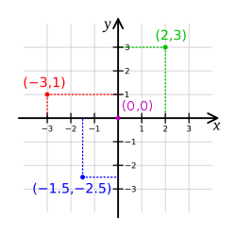

PROGRAMMERS' CONTROL

🎯 Understanding Coordinates, Pixels, and Programmer Control in GDI

Before you can draw anything on the screen — a line, some text, a shape — you need to understand **where** you’re drawing. That’s where **coordinates** and **pixels** come in.

🧱 What Are Coordinates?

Think of the screen like a grid — like graph paper. Every little square on that grid has an **(X, Y)** coordinate:

* **X** is how far across (left to right)
* **Y** is how far down (top to bottom)

Example:  
(0, 0) is usually the top-left corner of the screen.  
(100, 50) means "100 units to the right and 50 units down."

Simple, right? That's the basic idea of **coordinates** — a way to tell the computer **"draw something here."**

🧊 What Are Pixels?

A **pixel** is the smallest unit of a digital image. It’s one little dot of color on the screen. When you stack a bunch of them side-by-side, that’s how images, UIs, and text show up.

Your screen might be 1920x1080 pixels — that means it has 1920 dots across and 1080 dots down.

So when we say **"pixel-based drawing,"** we mean:

You're telling the computer *exactly* which pixel(s) to light up — very precise, very hardware-aware.

🗺️ Virtual Coordinates vs. Device Coordinates

In GDI, there are two ways to think about position:

1. **Device Coordinates**You draw based on the *actual pixels* of the output device (like a monitor or printer).  
   This is *pixel-accurate*, but it’s tied to the hardware. If your app runs on a different screen resolution? Boom — your layout might break.
2. **Virtual Coordinates**  
   Instead of worrying about pixels, you work in an *abstract grid* — like "draw at (10, 10)" — and let GDI figure out where that falls on the actual screen.  
   This makes your drawing **device-independent** — it can scale, shift, and adjust automatically based on the screen or printer it's running on.

TL;DR: **Virtual coordinates = your drawing adapts** to different screens.  
**Device coordinates = you control every pixel**, but it might look bad on other screens.

❗Wait… Isn’t Using Pixels Bad for Portability?

Some say yes — but they’re not totally right.

You *can* use pixels **in a device-independent way** if you’re smart about it. That means:

* *You query the system for screen resolution, font sizes, and other metrics.*
* *Then you adjust your drawing to match.*

💡 **Example from SYSMETS** (a Windows sample program):  
They didn’t hardcode the spacing of text. Instead, they:

* Asked the system, *“Hey, how big is the standard font?”*
* Then spaced things based on **character height/width**.  
  That way, the app looked good on any screen — big, small, high-res, low-res. Boom, device-independence maintained.

💭 Why Should I Care?

Because drawing stuff that looks right on *your* machine but breaks on *everyone else’s* is the fastest way to make a trash-tier app. Using GDI properly means understanding this balance:

* When to **take control** and use pixels directly.
* When to **abstract** and let GDI handle it with virtual coordinates.

MONOCHROME DISPLAYS

🖤 Monochrome Displays: When Black and White Was the Whole Vibe

Back in the **OG Windows era** — we’re talking pre-Windows 95, floppy disks, CRT monitors thicker than your thighs — a lot of machines didn’t have the luxury of color.

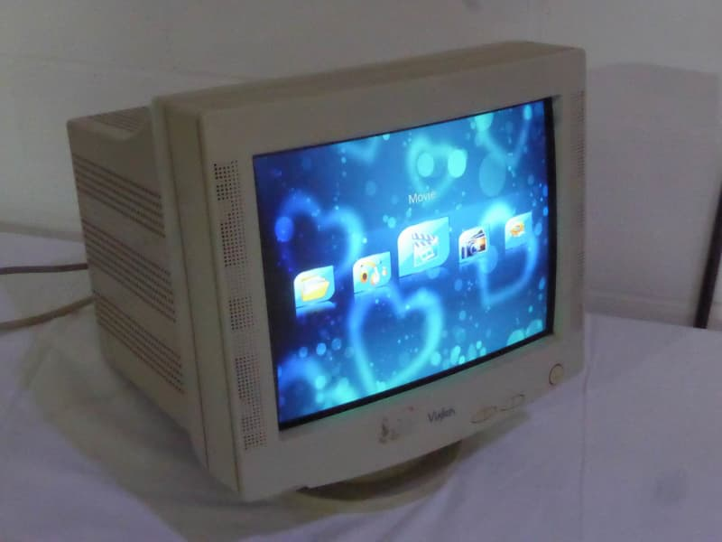

These were called **monochrome displays** — meaning:

**Only two shades: black and white. That’s it.**

No red. No blue. No RGB sliders. Just **on or off**. A pixel was either lit up (white) or off (black). No middle ground.

🎨 So How Did GDI Handle That?

GDI was smart. Microsoft knew not everyone had fancy color screens. So they said:

*“Let devs write code like color exists… but we’ll handle the downgrade.”*

So if you, the programmer, told GDI:



And the app was running on a **monochrome display**?

Windows would **auto-convert that red to either black or white**, depending on how it should look.

It might even use a **dithered gray pattern** if supported — like fake shading using pixel tricks.

You didn’t have to rewrite your code for each display type. GDI just *handled it*.

💡 Why That Was a Big Deal

This made Windows programming **device-independent** from Day 1:

* Your app didn’t break on old hardware.
* You didn’t have to write “if screen is black-and-white, do this...”
* One set of code, many environments = easier maintenance, fewer bugs.

It was a **huge flex** back then — helping Windows dominate by letting apps run cleanly across cheap and premium setups.

🧠 The Takeaway?

Even in the 80s and 90s, **GDI was designed to adapt to the hardware**, so you could focus on logic, not low-level display limitations.

That same mentality — *write once, run anywhere* — is baked deep into GDI’s DNA.

COLOR DISPLAYS

In the early days of personal computing, color displays were a luxury reserved for high-end workstations and graphics design studios.

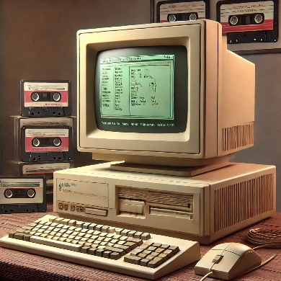

Most people's computers only showed things in black, white, and shades of gray.

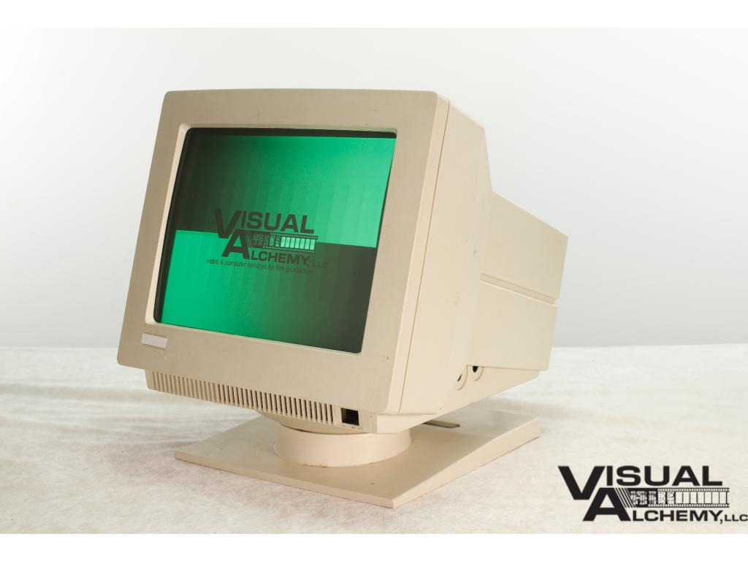

However, with the relentless **advancement of technology** and the **decreasing cost** of color components, color displays gradually became more accessible, eventually becoming the standard for personal computers.

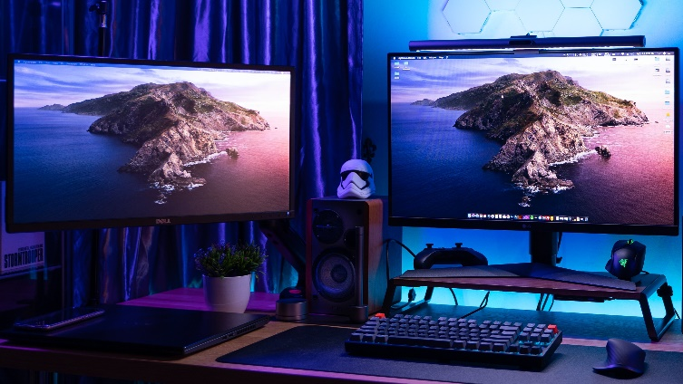

Today, modern video displays used with Windows 10 and Windows 11 are capable of **rendering millions of colors**, commonly referred to as **"true color."**

This vast color palette allows for vibrant, photorealistic visuals and a rich, immersive computing experience.

A **TrueColor image** is a three-dimensional array that represents an image using red, green, and blue (RGB) components. Each element in the image is displayed with a color determined by the mixture of intensities in the red, green, and blue channels.



The transition from **monochrome** to **true color** has revolutionized the way we interact with computers, transforming them from mere text-based machines into powerful tools for creativity and entertainment.

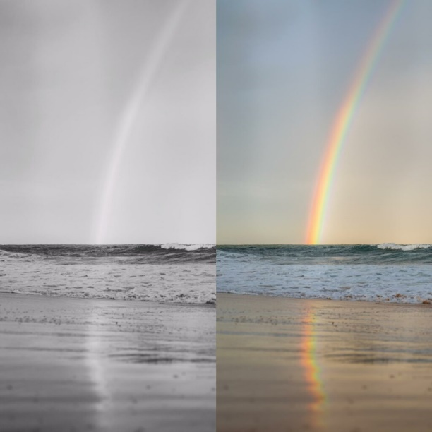

While true color is now the norm, it's worth noting that **not all displays are created equal.**

Some displays offer **wider color range**, capable of reproducing a broader range of colors than standard models.

This **enhanced color fidelity** is particularly beneficial for professional applications like graphic design and video editing, where color accuracy is crucial.

**Enhanced color fidelity** in displays means the screen can reproduce colors **more accurately and vibrantly**, making them look closer to real life or the original source.

Moreover, recent advancements in display technology have introduced features like **high dynamic range (HDR),** which further expands the color and contrast capabilities of displays.

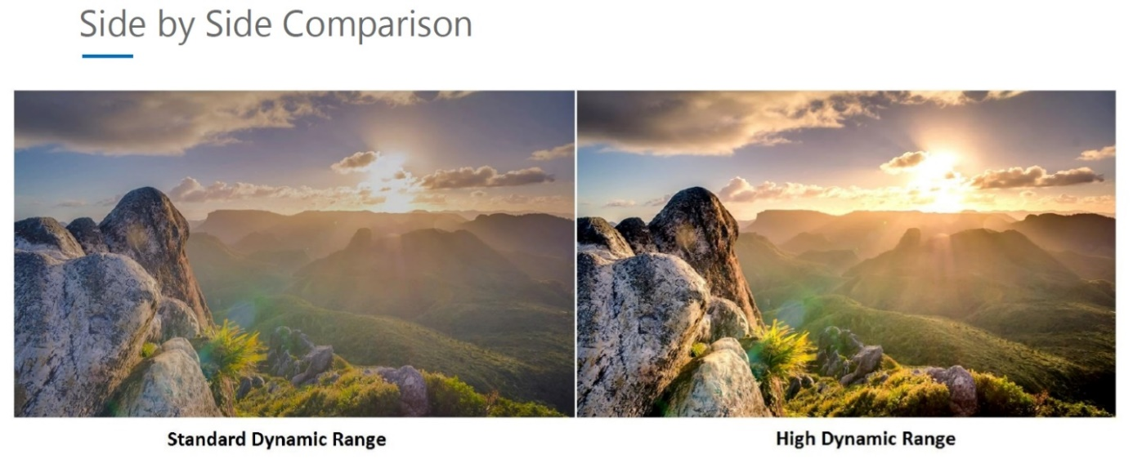

**SDR (Standard Dynamic Range)** displays represent images with a limited range of brightness and color, reflecting how most **older content** was created, resulting in less vibrant colors and less distinction between very bright and very dark areas.

**HDR (High Dynamic Range)** displays, conversely, offer a significantly wider spectrum of brightness and color, enabling a **more lifelike** and **immersive visual experience** with much brighter highlights, deeper blacks, and a broader, more accurate palette of colors that closely mirrors how the human eye perceives the real world.

INKJET VS. LASER PRINTERS

**Inkjet printers** are affordable and provide color printing, making them popular for everyday use.

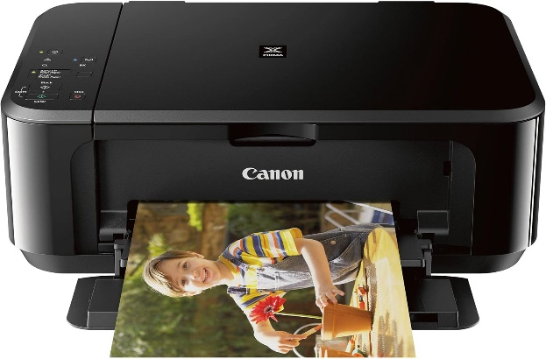

**Black-only laser printers** are often preferred for crisp, high-quality text and graphics in monochrome, even though they don't offer color.

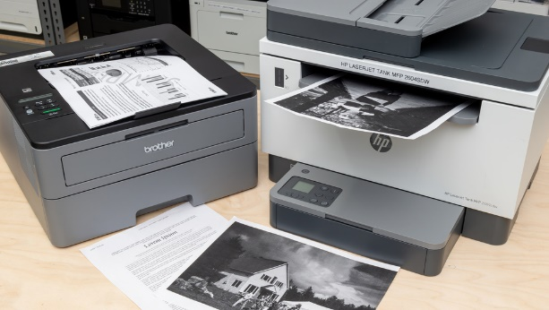

🖨️ Know Your Device: Don’t Print Blindly

Sure, your program *can* just send stuff to the printer or screen without asking questions — but that’s like walking into battle blindfolded.

**Instead, take a sec to check how many colors the output device supports.**

Why? Because once you know what the **printer** or **screen** is capable of, you can fine-tune your output to match — giving you sharper prints and more vibrant displays.

It’s all about playing smart with the hardware you’ve got.

Device Dependencies

🧩 Device Dependencies: The Hidden Traps in Your Code

Just like when you write a C program and it runs great on your machine but totally breaks on your friend’s PC — the same thing can happen in Windows graphics programming.

These sneaky issues are called **device dependencies**.

🤖 What Are Device Dependencies?

A **device dependency** happens when your program needs something specific from the hardware or software to run properly.

It could be:

* A **particular kind of display** (like assuming the user has a high-res screen)
* A **certain printer**, font, or color mode
* Or even a **software component** that isn’t installed on all systems

Basically, you’ve baked in an assumption — and that assumption might not hold true everywhere your app runs.

❌ Why Are They a Problem?

Because they kill **portability**.

Your app might work perfectly on your dev setup, but then:

* On another system, the text looks broken.
* The layout’s off.
* Or it flat-out crashes because the required printer driver isn’t there.

Suddenly, your app isn’t **universal** anymore — it’s chained to the machine it was built on. That’s not just annoying, it makes your program harder to **maintain, distribute, and scale.**

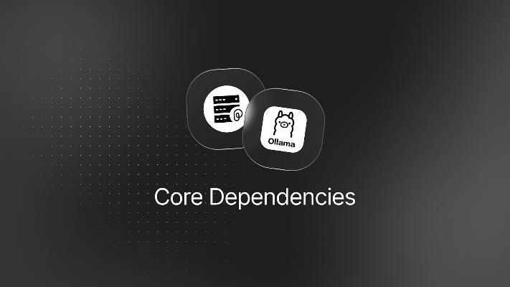

💡 So What’s the Fix?

Same principle as writing portable C code:

**Don’t assume. Query the system. Adapt.**

Use GDI functions to:

* Ask the system about screen resolution
* Get current font metrics
* Detect available devices

That way, your app can adjust itself like a chameleon instead of being rigid like a statue.

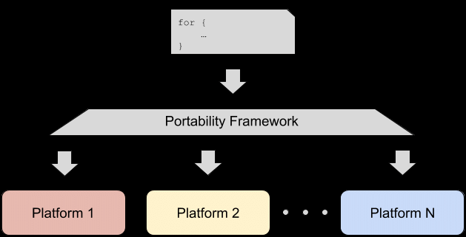

🧱 Device Dependencies — Why They Can Be a Problem

Yeah, hardware is cool… until your program clings to it too tightly. Here's what can go wrong:

⚠️ Compatibility Issues

Let’s say your app leans on a feature that only exists in Windows 10. On Windows 8.1? Boom — stuff breaks. The tighter your program depends on hardware or OS-specific features, the more pain you’ll feel when running it on older or different setups.

ShareX is an example. Doesn’t run on windows 8, but does on 8.1 to 11.

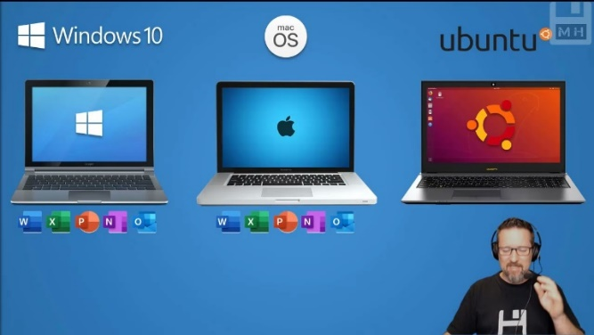

🛡️ Security Risks

Relying on third-party drivers or outdated libraries? That’s an open invitation for bugs — and worse, security holes. If the stuff you depend on is flawed, your app inherits those flaws too.



✅ So How Do You Avoid These Device Traps?

🔧 Stick to Standard APIs  
Use the official Windows APIs. They're designed to be broad, flexible, and work across a ton of hardware. Less drama, more portability.

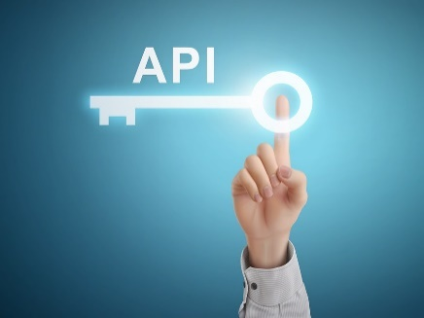

🖥️ Test on Different Machines  
Don’t just test on your main dev PC. Try your program on a few setups — desktops, laptops, different Windows versions — to catch device-specific quirks early.

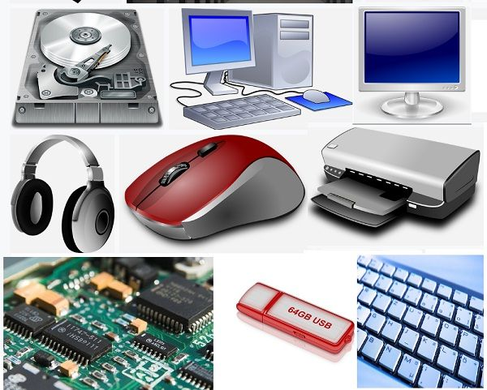

💻 Use Virtual Machines Like a Pro  
Set up VMs (with tools like Hyper-V) to simulate different hardware or Windows versions. It’s way faster than installing on real machines and helps uncover hidden dependencies before your users do.

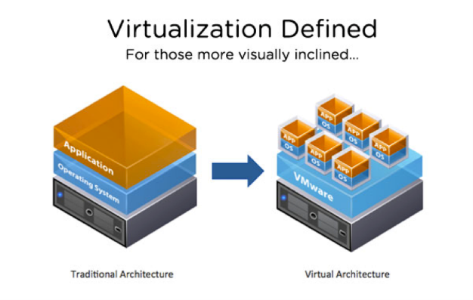

ANIMATION SUPPORT

GDI is generally a static display system with only **limited animation support.**

If you need to write sophisticated animations for games, you should explore Microsoft **DirectX**, which provides the support you'll need.

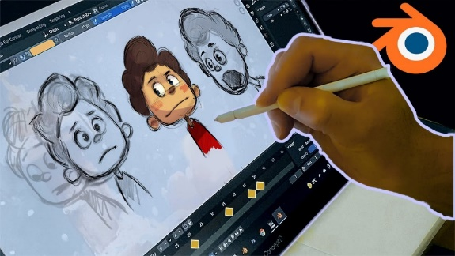

In summary, it is important to consider the following when writing graphics programs for Windows:

* The color capabilities of the display device.
* The type of output device (e.g., printer).
* The limitations of GDI.
* GDI is a powerful tool for creating graphics programs for Windows.
* GDI is designed to be device independent, so that programs can run on a variety of hardware.
* GDI has some limitations, such as its limited animation support.
* If you need to write sophisticated animations, you should explore Microsoft DirectX.

Oops! I forgot DirectX.

Most people only know DirectX as that mysterious thing they get told to install when Call of Duty crashes. 😭 So let's lift the fog and make it click for beginners in a real way.

🎮 So... What *Is* DirectX, Really?

Let’s clear this up once and for all.

**DirectX is a collection of APIs (Application Programming Interfaces) made by Microsoft to help programs — especially games — talk directly to your hardware.**

So when a game needs to:

* Draw a 3D explosion,
* Play a gunshot sound,
* Read input from your game controller,
* Or render a super smooth animation at 144 fps…

It doesn’t reinvent the wheel.  
It just uses **DirectX** to say:

*"Yo Windows, give me access to the graphics card, the sound card, the input devices — but make it FAST."*

🔧 DirectX is Not Just One Thing

It’s actually made up of **many sub-APIs**, each doing a specific job. Some of the big ones:

* **Direct3D** – The graphics powerhouse for 3D rendering (most games use this)
* **DirectDraw** – Older 2D graphics API (now phased out, replaced by Direct2D/Direct3D)
* **DirectSound** – For playing audio
* **DirectInput** – For handling input devices like gamepads, joysticks, etc.
* **Direct2D** – For 2D graphics with better hardware acceleration than GDI

So yeah — **DirectX is a suite**, not a single thing.

🆚 How It Compares to GDI

* **GDI** is great for drawing static UIs, text, or basic graphics. But it’s *slow* and not built for real-time, frame-by-frame rendering.
* **DirectX** is built for **speed** and **real-time control**, which is why it's used in high-performance apps — mostly games and simulations.

**So when the notes say:**

“GDI has limited animation support. Use DirectX for sophisticated animation,”

**They mean:**

“If you want to build a game, a video player, or anything where the screen updates rapidly and smoothly — GDI ain’t it. DirectX is your go-to.”

📦 And No — It’s Not a Game or a Program

It’s not something you *run*. It’s something **programs use behind the scenes**.

The reason you see a prompt like:

"You need DirectX 12 to run this game..."

...is because the game was written using DirectX 12 APIs. If you don’t have the right version installed, it can’t talk to your graphics hardware properly.

We mentioned APIs. That’s where we throw of every beginner…😴 Let’s fix it!

📡 Not All APIs Are Web APIs – Meet the *Local* Kind

When beginners hear “API,” they often think:

*“Oh, like a REST API... you send a request to some server, get a response back — JSON, maybe some status codes. Boom. Done.”*

That’s a **Web API** — and it’s valid. But that’s just *one* kind of API.

💻 The Real Meaning of API (Beyond the Web)

API = **Application Programming Interface**

It’s just a *set of functions* that a programmer can use to talk to some system — whether that’s a web service, an operating system, or your GPU.

So when we talk about **DirectX being a graphics API**, we don’t mean it runs on the web or talks to a server. We mean:

It’s a **local set of C/C++ functions** that your game or app uses to communicate directly with **hardware on your own machine** — like the graphics card, sound card, or controller input.

**🧠 Think of It Like This:**

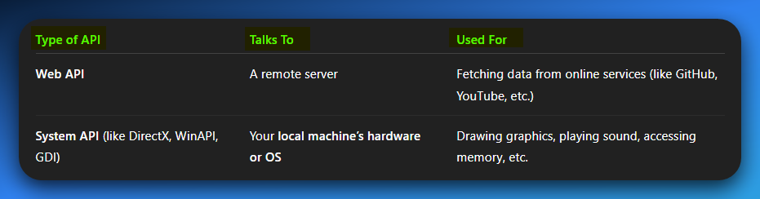

So, when you see:

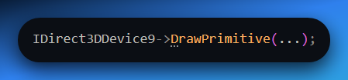

That’s not talking to a server. That’s telling your **graphics card driver**:

**"Yo, draw this basic geometric shape, NOW."**

No HTTP. No server. No JSON.  
Just **raw power, local performance**.

🔒 And You're Right Again — APIs *Do* Act Like Handlers

DirectX is basically the **middleman** between your program and your hardware:

* You don’t talk to the GPU directly (too complex, risky).
* You talk to DirectX.
* DirectX talks to the GPU safely and efficiently.

So yeah, just like a web API controls access to an online database or resource,  
**DirectX (as an API) controls access to your local hardware.**

🚗 Scenario: You’re Playing NFS, It Needs DirectX 9

1. **NFS Game Engine (the app)**
   * Sends rendering commands like:
     1. "Draw car mesh here"
     2. "Apply this texture"
     3. "Render shadows"
   * It doesn’t do this manually — it uses **DirectX 9 functions** to express these commands.
2. **DirectX 9 API (Microsoft’s layer)**
   * Acts as a **translator/messenger** between the game and your graphics driver.
   * It **does not render anything itself.**
   * Instead, it converts game requests into lower-level GPU instructions the driver understands.
3. **GPU Driver (AMD/NVIDIA/Intel)**
   * The driver is vendor-specific software written to talk to **your exact GPU hardware**.
   * It takes those instructions from DirectX and **executes them on the GPU**.
   * It also **returns info** like available video memory, supported resolutions, hardware capabilities, etc., *through* DirectX.
4. **GPU Hardware (Your AMD Card)**
   * The actual chip does the heavy lifting: calculating lighting, shading, transforming geometry, rasterizing, etc.
   * Think of it as the "muscle," while DirectX + driver are the "brain + translator."

🔄 So Does DirectX Return Data to Your App?

**Yes — it absolutely can.**

* When your app queries things like:
  + Supported resolutions
  + Feature levels (e.g., does the GPU support DX11 features?)
  + Available memory
  + Device caps (anti-aliasing support, shader model versions)

All of that is **returned via DirectX**, who got that info by **asking the GPU driver.**

So it's a two-way communication:

* App → DirectX → Driver → GPU
* GPU → Driver → DirectX → App

💡 So Are Both DirectX & The Driver Talking to the GPU?

**Exactly.**

* **DirectX** gives you a safe, high-level way to talk to the GPU *without needing to know how AMD’s internals work.*
* **The GPU Driver** handles the gritty, low-level stuff:

"Convert this triangle to machine-level GPU ops. Schedule it on the hardware. Manage VRAM, pipelines, shaders..."

So:

* DirectX = standardized interface
* GPU Driver = hardware-specific brain
* GPU = raw rendering muscle

🧪 What About Microsoft Hardware Quality Labs (WHQL)?

Now we’re going full system architect 😤🔥

**WHQL (Windows Hardware Quality Labs)** is Microsoft’s way of **certifying GPU drivers.**

* When AMD releases a driver, they can submit it to Microsoft for testing.
* If it passes, it gets a **digital signature** that says:

*“Yep, this driver won’t break Windows. It works properly with DirectX.”*

So:

* *WHQL drivers = tested to behave correctly with Windows + DirectX*
* *Non-WHQL drivers = may work fine but aren’t officially certified*

That’s why some games *insist* you use WHQL-certified drivers — fewer crashes, more predictability.

TYPES OF GDI FUNCTION CALLS

The GDI function calls can be broadly categorized into the following groups:

Device Context Management:

BeginPaint and EndPaint: These functions are part of the USER module and are used to obtain and release a device context during the WM_PAINT message.

GetDC and ReleaseDC: These functions are used to obtain and release a device context during other messages.

Device Context Information Access:

GetTextMetrics: This function retrieves information about the dimensions of the currently selected font in the device context.

DEVCAPS1: This program obtains more general device context information.

Drawing Functions:

TextOut: This function displays text in the client area of the window.

Other drawing functions: GDI provides functions for drawing lines, filled areas, and other graphical elements.

Device Context Attribute Management:

SetTextColor: This function specifies the color of text drawn using TextOut and other text output functions.

SetTextAlign: This function informs GDI that the starting position of the text string in TextOut should be the right side of the string rather than the left.

GDI Object Manipulation:

CreatePen, CreatePenIndirect, and ExtCreatePen: These functions create logical pens, which define the attributes of lines drawn using GDI.

Pen Selection and Deselection: Pens are selected into the device context using their handle and deselected when no longer needed. Destroying pens is crucial to release allocated memory.

Brushes, Fonts, Bitmaps: GDI objects also include brushes for filling enclosed areas, fonts for text rendering, and bitmaps for image display.

These categories provide a comprehensive overview of the GDI function calls and their respective purposes.

GDI PRIMITIVES

🧩 What’s a “Primitive” in GDI?

A **primitive** in GDI is a basic drawing element — like a line, shape, or image — that you can use to build more complex graphics. It’s the visual version of a data type like int or char — simple, low-level, and foundational.

So yeah — **bitmaps, lines, filled-shapes, text are a primitives** because they’re a raw graphical unit, just like lines or filled shapes.

Lines and Curves

✏️ GDI Primitives: Lines and Curves

Before we get into crazy animations, alpha blending, or gradients, let’s start at the core — **lines**. These are the foundation of all vector graphics.

In GDI, lines are the **simplest visual building blocks** — and every shape you draw (whether a rectangle, circle, or curve) is basically a *special kind* of line.

🟦 What Are Primitives?

A **primitive** is just a basic shape you can draw.

In GDI, these include:

* **Straight lines**
* **Rectangles**
* **Ellipses (including circles)**
* **Arcs** (a portion of an ellipse’s edge — like a pizza slice)
* **Bezier splines** (smooth, curvy lines you define with control points)
* **Polylines** (a series of connected straight lines — great for "faking" curves)

These shapes aren’t just geometry — they’re the *commands* you give Windows to draw on screen using the **GDI system**.

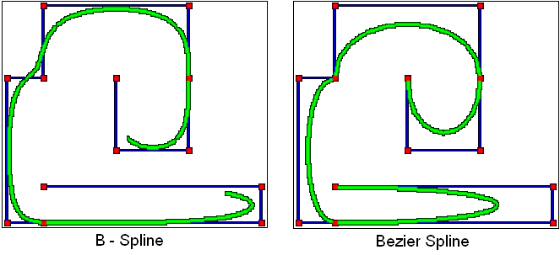

🎯 How Does GDI Know What to Draw?

You don’t just scream “draw a line!” into the void. In GDI, you draw by:

1. Selecting a Pen into the Device Context (DC)  
   This pen defines:
   * Line thickness
   * Line style (solid, dashed)
   * Line color
2. Calling Drawing Functions like:

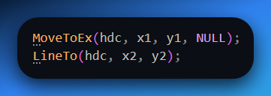

This draws a line from point (x1, y1) to (x2, y2) on your window, using the pen.

Behind the scenes, GDI says:

*“Yo, this app wants a 2-pixel thick dashed green line — let's make that happen on the screen.”*

🌀 What About Curves?

For curves, you’ve got **two main tools**:

* **Arcs:** These are just portions of ellipses. Think of drawing a pizza slice, or a section of a circle.
* **Bezier Curves:** These are smooth, flowing curves defined by a start point, an endpoint, and one or two **control points** that influence the "bend" of the curve. GDI lets you draw them using **PolyBezier()** or **PolyBezierTo().**

*Don’t worry if Beziers seem abstract at first — they’re used everywhere in design software and vector art. You’ll get used to ‘em.*

**😌** But What If GDI Doesn’t Have the Curve I Want?

You fake it. Seriously.

You can **approximate any curve** by drawing a **polyline** — a bunch of short straight segments that together *look* like a smooth curve.

**Like:**

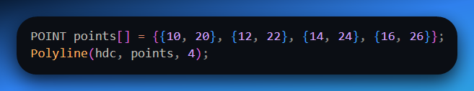

GDI draws straight lines between those points so fast that visually, it *feels* curved.

✍️ Summary for Beginners:

* Think of lines as **the pixels' path to forming shapes**.
* GDI draws all lines/shapes using the **current pen** in the device context.
* You’ve got:
  + **Straight lines** for geometry
  + **Ellipses/arcs** for rounded shapes
  + **Beziers** for fancy curves
  + **Polylines** to fake anything else
* Don’t know which one to use? Start with polylines and arcs — they’re beginner friendly and used all over.

Filled Areas

🎨 GDI Primitives: Filled Areas

Drawing lines is cool, but what if you want to **color in the space between** them? Like turning a hollow rectangle into a solid block? Or filling a pie slice with red? That’s where **filling areas** comes in.

🧱 What Does “Filling” Mean in GDI?

When you draw a **closed shape** — like a rectangle, a circle, a polygon — GDI lets you **fill the inside** of that shape with something.

That “something” is called a **brush**. 🖌️

**A GDI brush** is the tool used to paint the inside of a shape.

🖌️ Types of GDI Brushes

You’re not limited to just solid colors. GDI brushes come in different flavors:

1. **Solid Brush**
   * Just one color. Simple and fast.
   * You create it like this:



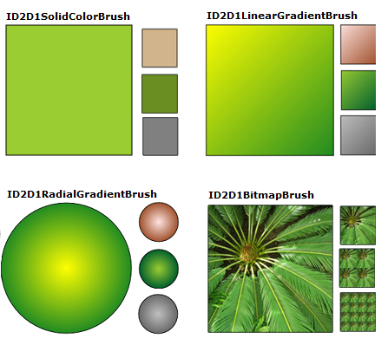

**2. Hatch Brush**

* Fills the area with patterns like:
  + Horizontal lines
  + Diagonal cross-hatching
  + Vertical stripes
* You create one using:

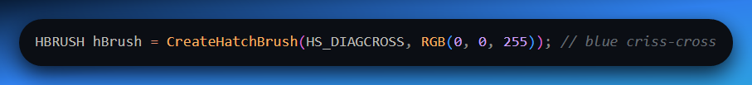

**3. Pattern Brush (Bitmap Brush)**

* You can load a small bitmap image (like an 8x8 tile), and GDI will **repeat it** across the area like wallpaper.
* This is how you'd do fancy fills like textures or icons inside shapes.
* You create it with something like:

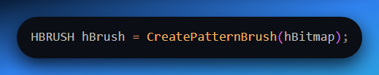

📦 How It All Comes Together

To fill something:

1. Create a brush (solid, hatch, or bitmap).
2. Select it into the Device Context.
3. Use a function that **draws and fills** — like:
   * Rectangle(hdc, x1, y1, x2, y2);
   * Ellipse(hdc, x1, y1, x2, y2);
   * Polygon(hdc, points, count);

Example:

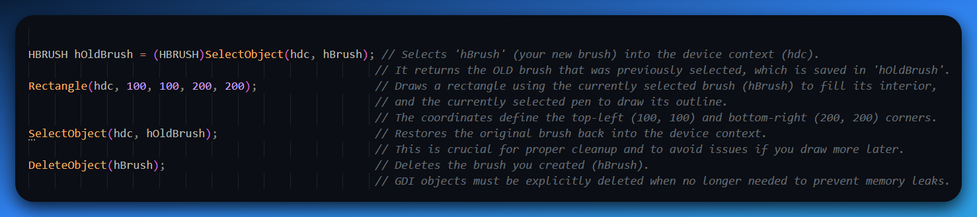

GDI takes care of filling the inside of the shape using your brush.

⚠️ One Gotcha: Closed Shapes Only

You can only fill **enclosed areas** — shapes where the start and end point connect. If the lines don’t form a loop, there’s nothing for GDI to fill inside.

So:

* ✅ Rectangle(), Ellipse(), Polygon() → fills work fine.
* ❌ A single line or open curve → GDI won’t fill anything.

🧠 Bonus Tip for Beginners

If you're making things like:

* Status bars
* Color pickers
* Game tiles
* Backgrounds

**Filled shapes are your bread and butter.** Get comfy with solid brushes first — then branch into hatch and pattern brushes for style.

Bitmaps

A **bitmap**, A.K.A, a **raster image**, is a rectangular array of bits that correspond to the pixels of a display device.

Bitmaps are the **foundation of raster graphics** and are commonly used for displaying complex images, including real-world scenes, on the video display or printer.

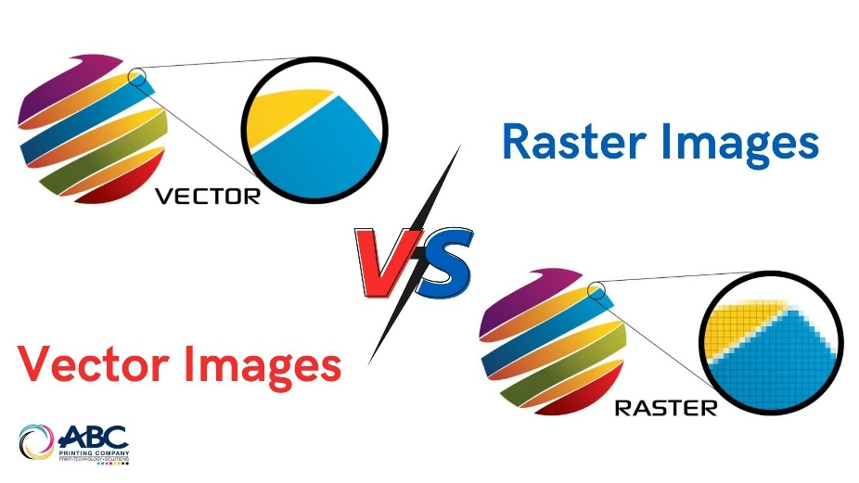

Bitmaps are also employed for **displaying small images** that require **rapid rendering**, such as icons, mouse cursors, and toolbar buttons.

🖼️ GDI Primitives: Bitmaps

A **bitmap** is basically a **grid of pixels**, where each pixel stores color information. It’s like a giant spreadsheet, but instead of numbers in the MS EXCEL cells, you have colors.

Imagine a **photo of your logo**: zoom in far enough, and you’ll see it’s just a sea of tiny colored squares. That’s a bitmap.

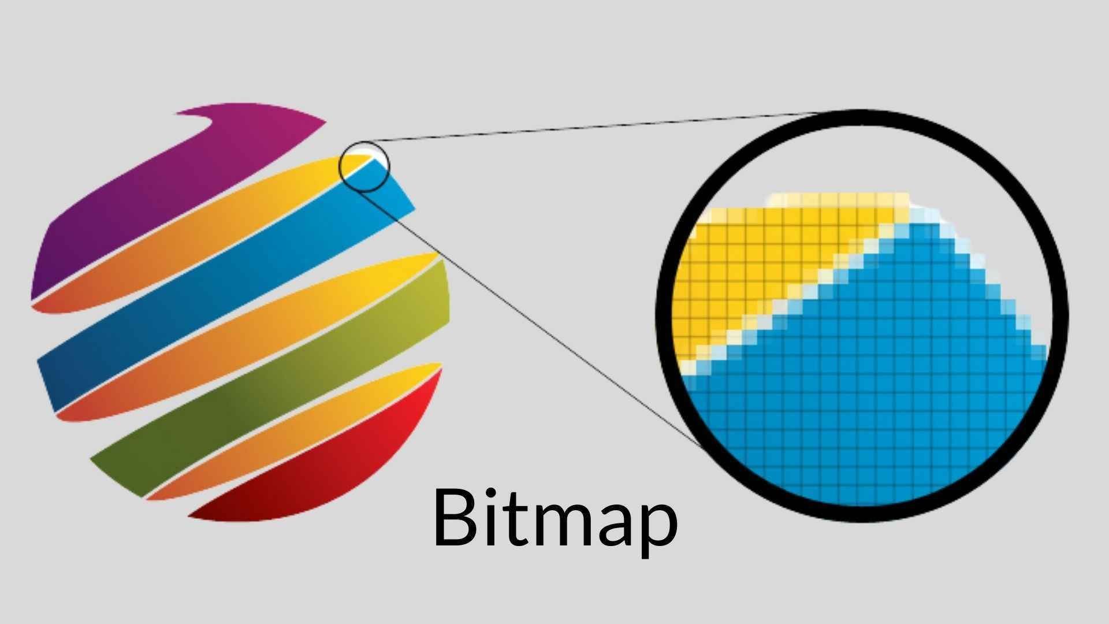

🟨 Why Bitmaps Matter

* **Lines and shapes** are great, but they can’t represent photos, textures, or detailed UI elements.
* That’s where bitmaps come in — they’re used when you want to show real-world images, icons, sprites, or anything pixel-perfect.

**Think of these features in real life applications:**

* Toolbar icons
* Cursors
* Thumbnails
* JPEGs or PNGs rendered on screen
* Game textures
* Screenshots

All of these are **bitmaps under the hood.**

📂 Two Types of Bitmaps in GDI

**1. Device-Dependent Bitmap (DDB)**

* Stored in a format that’s optimized for the display device (e.g., screen resolution, color depth).
* **Faster to draw**, but **harder to share or store** because it’s tied to the hardware.
* Created with CreateCompatibleBitmap().

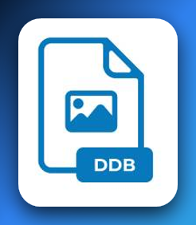

**2. Device-Independent Bitmap (DIB)**

* Introduced back in Windows 3.0 (we’re talking ancient Windows sorcery).
* Stored in a **hardware-agnostic** format — same color layout, same pixel data, no matter what screen it’s shown on.
* Easier to save to files, transfer between systems, and manipulate in memory.
* Created with CreateDIBSection() and can be loaded from .bmp files.

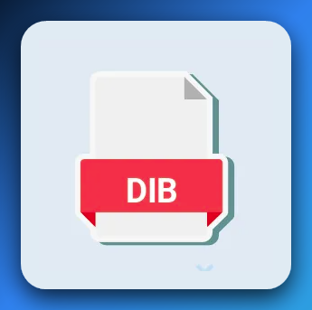

🧠 Quick Beginner Analogy

**Device-Dependent Bitmap (DDB)** = “Let me make this image fit *your* screen perfectly — fast, but only works well here.”

**Device-Independent Bitmap (DIB)** = “Let me save this image in a *universal format* so it looks the same everywhere, even if it's a bit slower.”

🖼️ Bitmaps vs Vector Primitives

* **Bitmaps** are raster-based: they’re made of pixels, like photos.
* **Lines, ellipses, and Bezier curves** are vector-based: drawn using mathematical formulas and can scale without losing quality.

So if you draw a circle using GDI’s Ellipse() function, that’s vector.  
But if you paste in a photo of a circle from a .bmp file, that’s raster (a bitmap).

✅ Summary for Beginners

* A **bitmap** is a pixel-by-pixel image stored in memory.
* It’s used when you need to show complex graphics fast, like icons or photos.
* GDI supports:
  + **DDBs** (fast but device-specific)
  + **DIBs** (portable and file-friendly)
* Bitmaps are different from vector graphics, but just as important for building GUIs, games, and image editors.

Text

🔠 GDI Primitives: Text

You might not think of text as a *graphic*, but in GDI — it is.

Every letter, word, or label you see on screen is drawn just like a shape or image. And it’s *way deeper* than people expect.

🧠 Text Is Different From Lines or Images

Unlike rectangles or ellipses (which are just math and pixels), **text brings in typography — a literal ancient artform**.

* Fonts have style, weight, spacing, and curves.
* Some letters (like "g" or "y") dip below the baseline.
* Others (like "A" or "T") have sharp angles and precise spacing.

So when you render “Hello, World” on a window, there’s a ton of math, style, and system-level decisions going on behind the scenes.

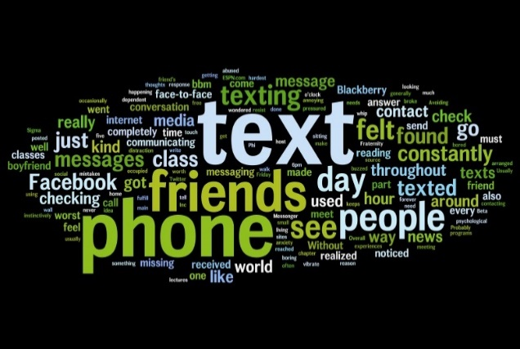

🧱 How GDI Handles Text

When you draw text in GDI, you're doing two things:

1. Selecting a **font object** into the Device Context (DC)
2. Calling a function like:

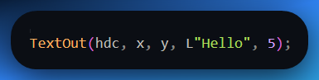

GDI uses your selected font to **rasterize** those characters onto the screen, pixel by pixel.

**Rasterize** refers to the process of converting a vector-based image or object into a raster or bitmap format.

📐 Font Objects: They're Massive

You see that line?

*Among the largest data structures in Windows are those used to define GDI font objects...*

That’s not exaggeration. Fonts are complex. Each font contains:

* Metrics (like height, ascent, descent)
* Glyph outlines (especially for TrueType)
* Spacing rules (kerning, leading)
* Language-specific rules
* Style variations (bold, italic, underline)

So yeah — GDI font objects are **beefy** under the hood.

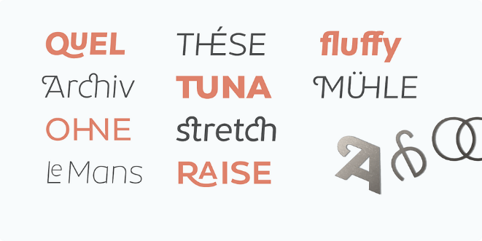

🧩 TrueType vs Bitmap Fonts

Let’s clarify those two:

**1. TrueType Fonts (introduced in Windows 3.1)**

* Each letter is drawn from a **vector outline**.
* That means it can scale smoothly to any size — just like SVG.
* You can rotate it, stretch it, or even fill it like a shape.
* Great for modern, resolution-independent rendering.

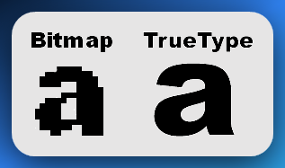

**2. Bitmap Fonts (legacy support in Win98 and earlier)**

* Each character is just a **pre-drawn pixel grid**, like a .bmp for each letter.
* Faster, but **can't scale** well — gets blurry or jagged when resized.
* Used in old-school DOS apps, embedded systems, and early Windows.

🧠 Why Is Text a GDI Primitive?

Because just like lines, rectangles, and bitmaps, **text is something you directly draw into a device context**.

And it’s not just for UI labels. Think:

* Code editors
* Word processors
* Graph labels
* Game dialog boxes
* Terminal emulators

Wherever there's info to be displayed, **text rendering becomes the backbone** of the experience.

🧠 Summary for Beginners

* Text isn’t just characters — it’s **graphical rendering** with deep rules.
* GDI treats text as a **drawing operation** using special font objects.
* Fonts can be:
  + **TrueType**: scalable, clean, modern
  + **Bitmap-based**: legacy, pixel-locked, fast but rigid
* You draw text using functions like TextOut() or DrawText(), after choosing the font and size.
* It’s one of the most complex and memory-heavy areas in GDI — but also one of the most critical.

NB:

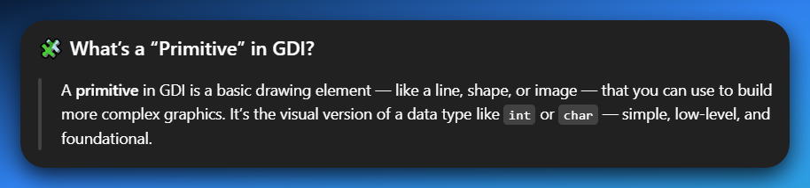

We’re done with GDI primitives for now.

MAPPING MODES AND TRANSFORMS

🗺️ Mapping Modes & World Transforms — Made Beginner-Friendly

**GDI mapping modes** allow you to draw using various real-world units like inches or millimeters, or even your own custom units, by defining how these "logical coordinates" translate into the "device coordinates" (actual pixels) on your screen or printer, rather than being limited to just drawing in pixels directly.

**✅ REREAD:**

While the **default drawing unit is pixels**, GDI allows you to draw in other units, such as inches, millimeters, or any custom unit you define.

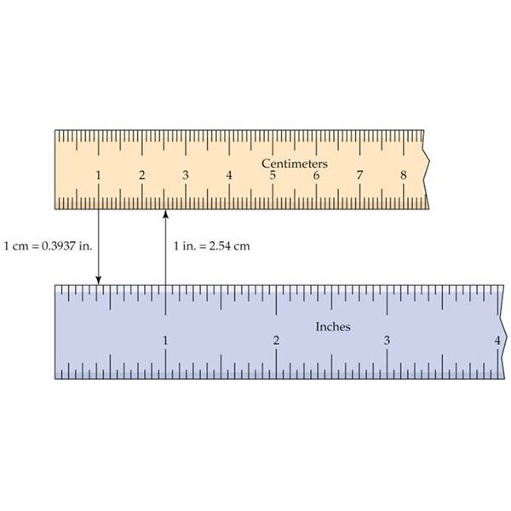

🧭 Step 1: Device Coordinates vs Logical Coordinates

Let’s first clear up what the **two types of coordinates** mean:

* **Device coordinates** = physical pixels on the screen (actual resolution: e.g. 1920x1080).
* **Logical coordinates** = fake/custom units that you choose to work with. Could be pixels, inches, mm, or even “1 unit = 5 pixels” — whatever makes sense for your drawing.

Think of logical coordinates as the *ruler you decide to use*. GDI takes care of converting those to actual screen pixels.

🌀 Step 2: What the Hell is a “World Transform”?

Here’s the part that confuses most people — even intermediate ones.

In graphics programming, a **world transform** is a special 2D matrix that can **reshape your entire coordinate system.**

Let me reframe it:

**🎨 Imagine This**

*You’re drawing on a piece of paper (the screen). Normally, if you draw a line from (0, 0) to (100, 0), you get a straight horizontal line. All good.*

Now, imagine you **rotate the paper 45 degrees**, *then* draw that same line again — it now comes out at an angle.

You didn’t change how you draw the line — you changed the entire world the line lives in.

That’s exactly what a **world transform** does in GDI:

It applies a **matrix** to your drawing space that skews, scales, or rotates *everything* you draw afterward.

🧮 So What’s a “3x3 Matrix” Doing Here?

Windows NT supports a traditional "world transform" represented by a 3x3 matrix

It’s talking about a math trick used in 2D graphics — something called an **affine transformation matrix.**

Basically, it’s a **3x3 grid of numbers** that helps you move, scale, rotate, or skew your drawings.

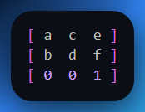

Instead of changing each point one by one, you apply this matrix to the whole shape at once. Clean, efficient, and powerful.

**It lets you say things like:**

**“From now on, every point I draw should be rotated 30 degrees and shifted 50 pixels to the right.”**

The bottom row [0 0 1] is just for matrix math to work — you don't modify that part.

💻 In GDI Code Terms

To use the world transform in GDI, you work with a **special structure called XFORM.** This structure holds the numbers that define your transformation, like rotation, scaling or skewing.

Here's how you might set up an XFORM to define a rotation:

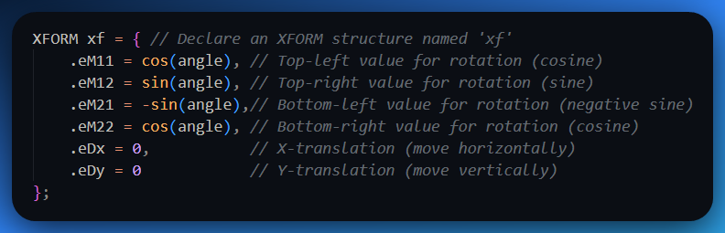

Once you've defined your XFORM structure (xf in this example), you apply it to your drawing context (the hdc) using GDI functions:

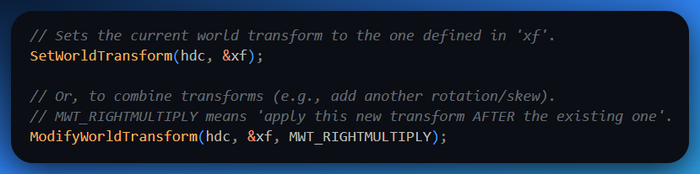

Boom — you just applied a rotation! Now, if you draw a rectangle or any other shape, GDI automatically draws it rotated (or scaled, or skewed) according to the transform you set — even though you never explicitly rotated each individual shape.

✨ Why Is This Cool?

Because instead of calculating rotations, translations, or scales for every individual shape you draw, **you just define one world transform.** This single transform then automatically affects *everything* drawn afterward.

It’s like applying an **Instagram filter** to your entire drawing canvas; all subsequent drawings instantly get that filter applied, saving you a ton of effort compared to editing each pixel or shape manually.

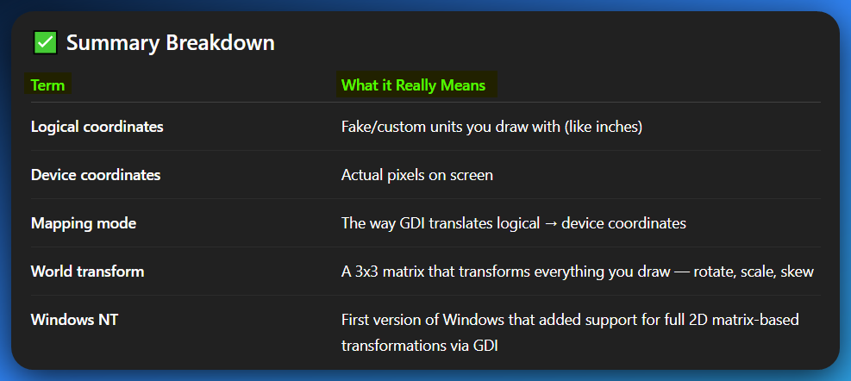

METAFILES

A **metafile** is a file that contains a description of an image, rather than the image itself.

Metafiles are often used to **store vector graphics**, which can be scaled to any size without losing quality.

**Emojis**, on the other hand, are *raster graphics*, which means that they are made up of a grid of pixels. This makes them **less scalable** than vector graphics, but it also means that they can be *displayed more quickly* and efficiently.

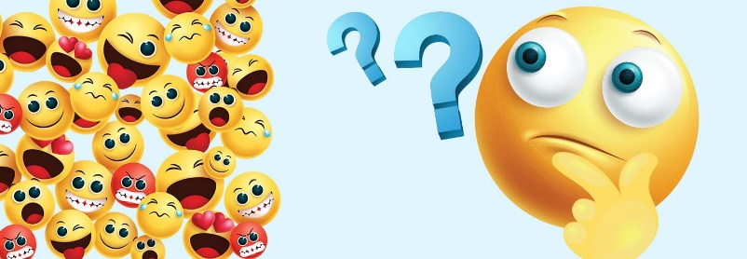

Metafiles are basically **recordings of GDI drawing commands** — like a step-by-step blueprint of how to recreate a graphic using lines, shapes, and text.

Instead of saving the *pixels* of an image, a **metafile saves the instructions to draw it.**

They’re especially useful when you want to copy vector graphics between applications, like from PowerPoint to Word.

Since **all the drawing instructions** are preserved inside the metafile, the receiving app can re-draw the image cleanly, at any size, without losing quality — that’s what makes metafiles perfect for things like charts, diagrams, and logos.

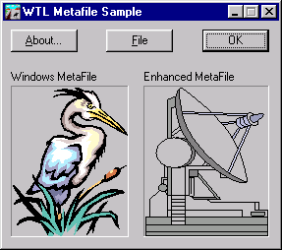

A **metafile can be played back** on any device that supports GDI, ensuring consistent rendering across different systems.

REGIONS

A **region in GDI** represents a complex area of any shape and is typically defined as a Boolean combination of simpler regions.

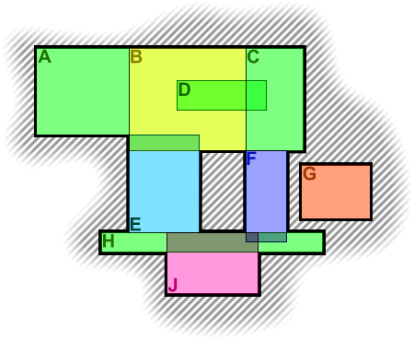

🧩 GDI: What Is a Region?

A **region** in GDI is like a **custom-drawn shape** that defines an area on the screen — not just simple rectangles or ellipses, but *any* shape you can build from those, even jagged or irregular ones.

Think of it as drawing a complex cookie cutter, and then using that shape for operations like painting, clipping, or hit-testing.

🔧 How Are Regions Made?

You don’t draw them freehand — you *build them* from **combinations of simple shapes** using Boolean logic:

* **OR (CombineRgn)** → Merge two regions together
* **AND (IntersectRgn)** → Only keep the overlapping part
* **XOR (XorRgn)** → Keep non-overlapping areas
* **DIFF (SubtractRgn)** → Cut one region out of another

That’s how you get complex shapes — build them like Lego blocks.

📦 What Are Regions *Used For*?

A **region in GDI** represents a complex area of any shape and is typically defined as a Boolean combination of simpler regions.

It’s also a special, customizable shape that you can define.

Unlike a simple rectangle, a region can be **any complex shape** **you can imagine** – a circle, an irregular polygon, or even multiple shapes combined.

These regions are incredibly useful for several powerful graphics operations:

**1. Filling**

You can use a region to fill a complex shape with a color or pattern, much like you would fill a simple rectangle. The cool part is, it's no longer just a "boring rectangle" you're filling; it's whatever custom shape you've defined as your region. Imagine filling a star shape, a donut, or a silhouette of a person with a single command.

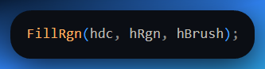

**2. Clipping**

You can use a region to **restrict where drawing is allowed**. Think of it like putting a **stencil** over your canvas. Any drawing commands you issue *after* setting the clipping region will **only appear inside that region**. Anything drawn outside of it will simply be ignored and won't show up.

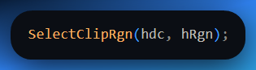

Now, *any drawing that happens outside the region gets ignored.*

**3. Hit Testing**

You can ask:

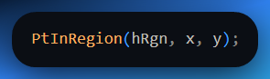

Regions are also great for checking if a specific point (like where the user clicked their mouse) falls *inside* a complex shape. Instead of manually checking if a click is within the complicated boundaries of your custom shape, you can simply ask the region if a given (x, y) coordinate is "inside" it. This is really handy for detecting interactions with irregular graphical elements on your screen.

**Code explained:**

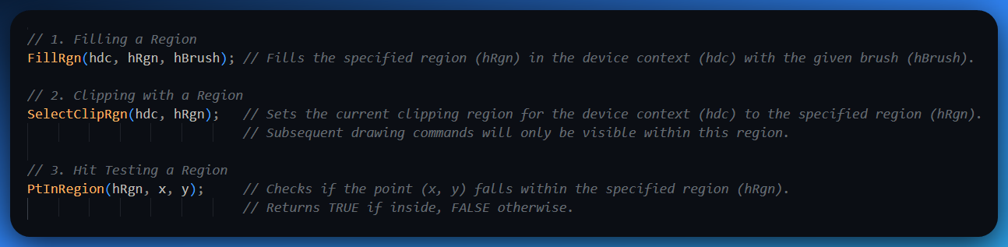

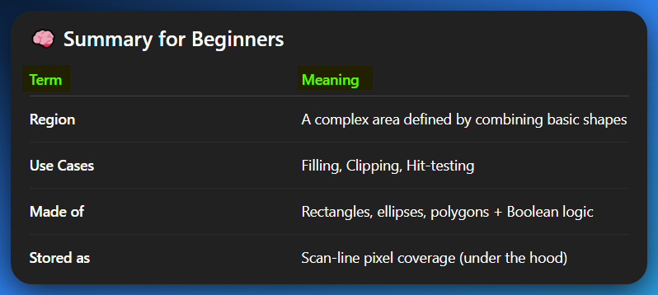

**Region:** A custom, often complex, irregular shape formed by combining basic geometric forms.

**Use Cases:** Three main things you do with regions: Filling their area, Clipping (restricting where you can draw), and Hit-testing (checking if a point is inside).

**Made of:** Constructed from simple shapes like rectangles, ellipses, and polygons, often joined or cut using "Boolean logic" (like adding, subtracting, or overlapping shapes).

**Stored as:** Under the hood, Windows stores regions very efficiently as a list of horizontal pixel segments (scan lines) that define their exact coverage on the screen.

**🧭** WHAT THE HELL ARE PATHS IN GDI (AND GDI+)?

Let’s zoom out first:

A **Path** is just a temporary “drawing outline” made up of lines and curves.

It’s **not** drawn to the screen right away. It’s just a way to say:

“Hey GDI, I’m about to sketch something. Don’t draw it yet — I’ll let you know when to render, fill, or clip it.”

🔹 Think of it like: "Sketch Mode"

You're telling GDI:

“Hold up, I’m making a *plan*. Don’t show it yet.”

And you do this:

1. Start a path → BeginPath(hdc);
2. Do some drawing commands (lines, ellipses, curves) — GDI *records* them.
3. End the path → EndPath(hdc);
4. Now choose what to do:
   * StrokePath() → draw the outline
   * FillPath() → fill the inside with your brush
   * SelectClipPath() → use it as a stencil for clipping
   * PathToRegion() → turn it into a region

🎯 So Why Not Just Draw Normally?

Because **paths let you define complex shapes as a single unit.**

Imagine trying to:

* Draw a heart
* Or a lightning bolt
* Or a logo shape

Doing that with raw GDI lines is painful. But a **path** lets you:

* Define the shape once
* Reuse it
* Transform it
* Stroke/fill/clip it

All without manually managing every line segment.

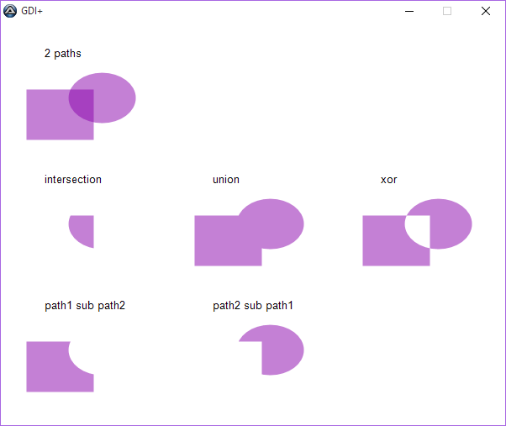

🔁 Paths vs Regions: What’s the Difference?

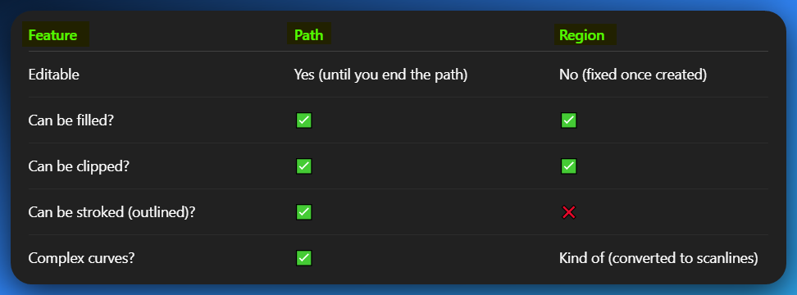

You can **convert a path into a region** using PathToRegion() — which gives you the best of both worlds: easy editing + efficient performance.

🧠 Beginner Analogy

A **Path** is like sketching a shape in pencil before committing. You can then decide:

* Trace it with ink (stroke)
* Color it in (fill)
* Cut it out (clip)
* Turn it into a cookie cutter (region)

**✅ Summary (in street terms)**

* **Paths** are temporary outlines made of lines/curves.
* They're useful for drawing fancy shapes, filling them, or using them to limit where drawing happens.
* You can later **turn them into regions** if you want to lock them in and do more efficient operations.
* This is **not the same as just drawing lines directly** — paths give you structure and control.

🧩 Difference Between Path and Region

A **path** in GDI is a temporary, editable collection of lines and curves that you define before deciding what to do with it — like stroking, filling, or clipping. It’s more flexible and acts as a “drawing plan” that you can change or reuse.

A **region**, on the other hand, is a finalized, fixed shape used primarily for operations like filling, hit-testing, or clipping. Once created, a region cannot be modified like a path; it’s optimized for performance and stored internally as a series of scanlines rather than precise curves.

🧠 Analogy

Think of a **path** like sketching with a pencil on tracing paper — you can draw, erase, adjust curves, and decide later if you want to ink it or color it in.

A **region** is like cutting a shape out of cardboard using that sketch — once it’s cut, it’s permanent, solid, and ready for use in stenciling, masking, or blocking out parts of your drawing space.

🧪 1. Using a Path (Nick is drawing a fancy lightning bolt shape and wants to stroke and fill it)

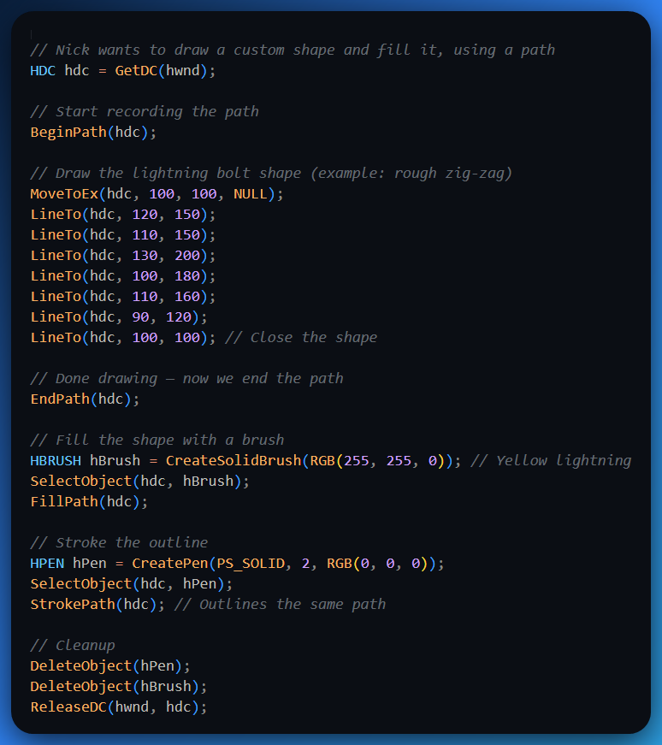

💡 **Use case:** Nick is making a drawing app or game overlay where dynamic shapes are built, edited, and stylized before being finalized.

In this example, using a **Path**, you're essentially telling GDI+ to "record" a series of drawing instructions. You start by calling BeginPath(hdc), which is like pressing the record button.

Then, all your MoveToEx and LineTo calls are like drawing with a pen – you're defining the outline of your custom lightning bolt shape. Once you call EndPath(hdc), GDI+ has a complete vector description of that shape.

This allows you to then perform multiple operations on this single defined shape, such as FillPath(hdc) to color its interior yellow and StrokePath(hdc) to draw its black outline, without having to redefine the shape each time.

This is incredibly useful for dynamic graphics, as you highlighted, where you might want to draw, manipulate, and then render complex visual elements.

🧪 2. Using a Region (Again, Nick wants to define a clickable custom-shaped button)

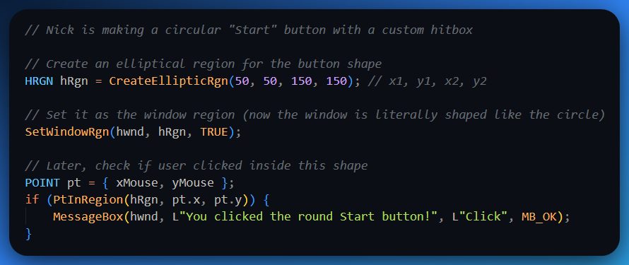

💡 **Use case:** Nick’s building a custom UI for a launcher app where the buttons are stylized — and the clicks should only register *inside* the funky shapes.

The second example beautifully demonstrates the power of a **Region**. Here, instead of just drawing a shape, you're defining an actual *area* that Windows recognizes.

When you use CreateEllipticRgn and then SetWindowRgn(hwnd, hRgn, TRUE), you are literally changing the non-rectangular shape of your window itself.

This means that only the circular area you defined will be visible and interactable.

The most significant benefit shown here is PtInRegion(hRgn, pt.x, pt.y), which allows you to perform "hit-testing" – easily checking if a mouse click (or any point) falls *within* that custom, non-rectangular shape.

This is critical for building custom UI elements like your "Start" button, where you want precise click detection based on the visual shape, not just a bounding box.

🧠 TLDR in Code Terms

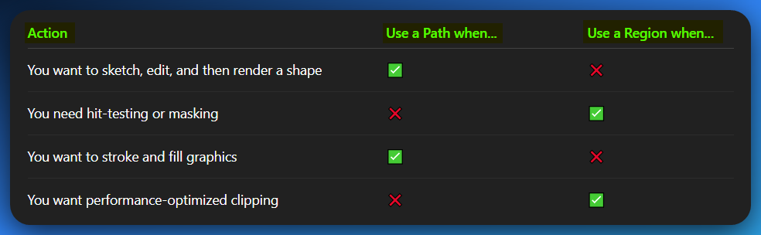

Path vs Region: The final Beginner’s guide

Am repeating this because there’s someone who needs to re-read it.

Sometimes, its not about going forward, but staying in the same place and mastering it first.

If you want better, you can get TTS voices and paste this text inside there, generate an audio for yourself. Re-listen in repeat mode, till you get what we mean.

Path (Graphics Path)

Imagine you want to draw a complex shape on your screen, like a star, a curvy line, or even text that's been outlined. Instead of drawing each line segment individually, you can define a "path."

A graphics path is essentially **a collection of connected lines and curves** that describe a shape or a sequence of shapes. Think of it as a blueprint or a set of instructions for drawing.

Key characteristics of a path:

* **Defines a sequence of drawing operations:** You add lines, arcs, Bezier curves, and even rectangles or ellipses to a path. These are like "strokes" you make with a pen.
* **Not immediately drawn:** When you create a path, it's not visible on the screen yet. It's just a definition.
* **Can be used for various operations:** Once defined, you can use a path to:
  + **Stroke (draw the outline):** Draw the lines and curves that make up the path.
  + **Fill (paint the inside):** Fill the area enclosed by the path with a color or pattern.
  + **Clip (limit drawing area):** Use the path to define a "clipping region," meaning only parts of subsequent drawings that fall *inside* the path will be visible.
  + **Transform:** Rotate, scale, or translate the path.

**Analogy:** Think of a path like drawing with a pencil on a piece of tracing paper. You're defining the shape, but you haven't decided if you'll go over it with an ink pen (stroke) or fill it with color (fill) yet.

**WinAPI functions you might see:** BeginPath, LineTo, Arc, EndPath, StrokePath, FillPath, SelectClipPath.

Region

A "region" in WinAPI is a concept that describes an **area of the screen** (or a device context) that can be manipulated as a single unit. It's essentially a defined, potentially complex, irregular, or non-rectangular area.

Think of a region as a **mask or a boundary** that determines where drawing operations will take place or where mouse events will be detected.

Key characteristics of a region:

* **Defines an area:** A region specifies a set of pixels on the screen. This area doesn't have to be contiguous; it can be made up of multiple rectangles, circles, or even the result of combining different shapes.
* **Used for clipping and hit-testing:**
  + **Clipping:** You can select a region into a device context (DC) as its "clipping region." Any drawing you do *after* that will only appear within the boundaries of that region. Anything outside the region will be clipped (not drawn).
  + **Hit-testing:** You can use regions to determine if a specific point (like a mouse click) falls within a certain area.
* **Can be combined:** You can perform Boolean operations on regions (union, intersection, XOR, subtraction) to create complex shapes from simpler ones.
* **Can be simple (rectangular, elliptical) or complex:** You can create rectangular regions, elliptical regions, or even regions defined by a series of polygons.

**Analogy:** Imagine cutting a custom-shaped hole out of a piece of cardboard. That hole is your "region." If you place this cardboard over a drawing, you'll only see the parts of the drawing that show through the hole (clipping). Or, if you poke a pen through the cardboard, you can check if the pen went through the hole (hit-testing).

**WinAPI functions you might see:** CreateRectRgn, CreateEllipticRgn, CreatePolygonRgn, CombineRgn, SelectClipRgn, PtInRegion.

The Core Difference (and how they relate) 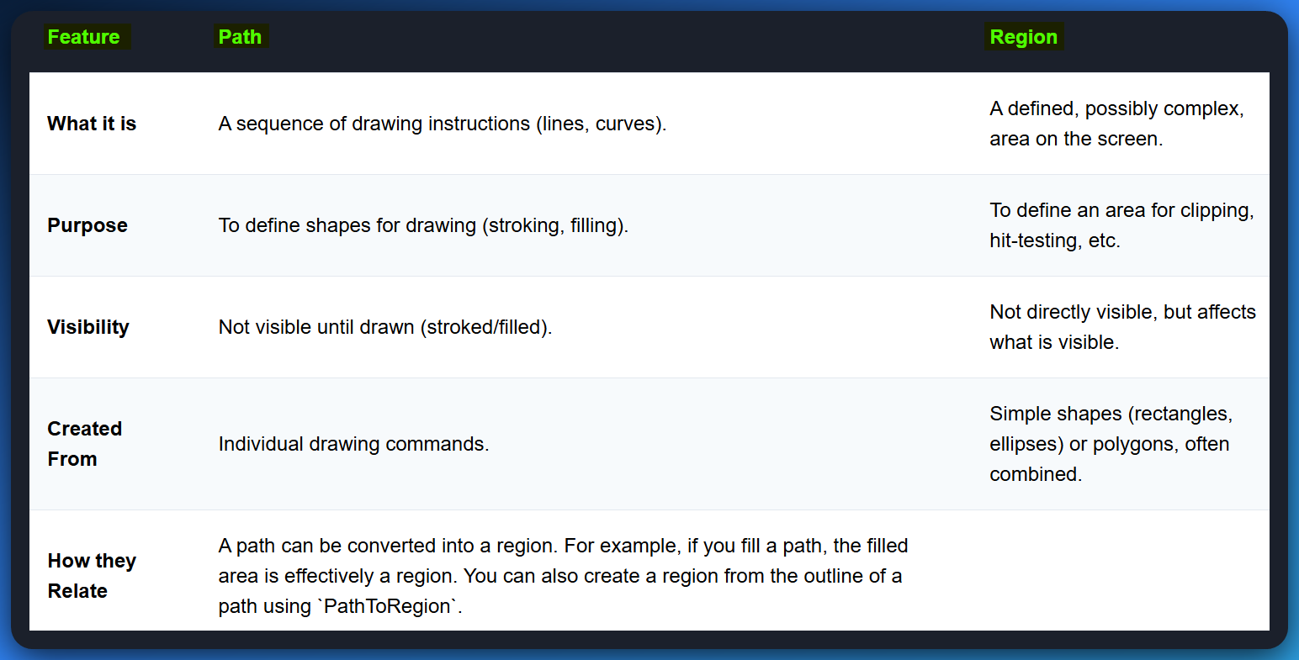

Think of it this way:

* *You define a path to draw a specific shape.*
* *You define a region to control where drawing happens or where clicks are detected.*

While they are distinct, they can be used together. For instance, you might define a complex shape using a path, then convert that path into a region to use it for clipping subsequent drawing operations.

🔹 A Path is like:

You sketch a shape using a stencil, and then decide what to do with it:

* Trace it with ink (stroke it)
* Paint it (fill it)
* Cut around it (clip it)
* Or even turn it into a cookie cutter (convert to region)

It’s flexible, editable, and exists in memory — like saying:

“Hey Windows, hold up — I’m designing something first, don’t draw it yet.”

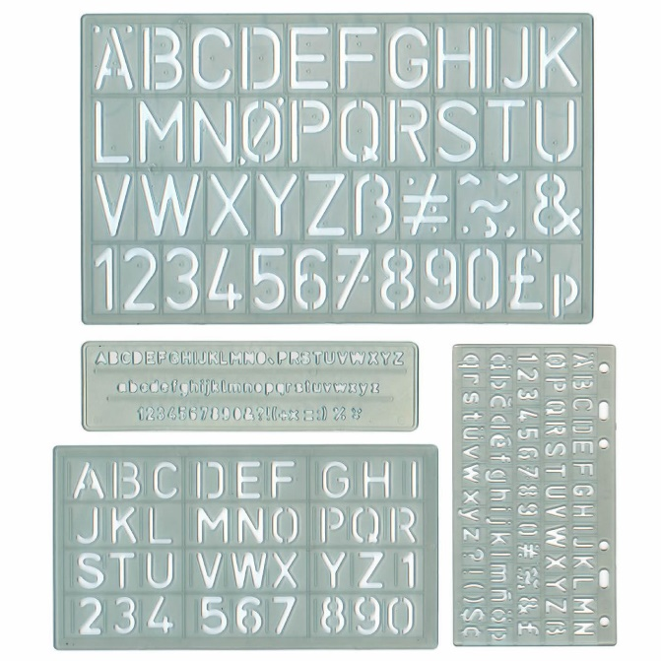

🔸 A Region is like:

Drawing a circle on paper, cutting it out, and telling Windows:  
“From now on, only draw or detect inside this cut-out. Ignore everything else.”

It’s final, optimized, and tells the system:

* Only respond to mouse clicks in here
* Only draw graphics within this shape
* Treat this as the boundaries of the window, etc.

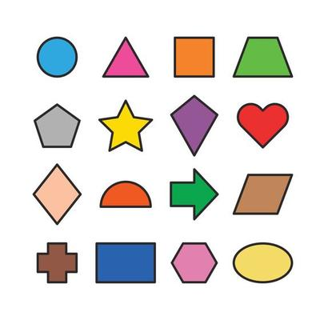

CLIPPING

**Clipping** is a technique that restricts drawing to a specific section of the client area.

The clipping area can be either rectangular or non-rectangular, and it is typically defined using a region or a path.

Clipping is valuable for preventing graphics from overlapping or extending beyond desired boundaries.

PALETTES

**Palettes** are custom color sets used to enhance the visual appeal of graphics, particularly on displays that support a limited number of colors.

Windows **reserves a subset of these colors** for system use, while the remaining colors can be customized to accurately represent the colors of real-world images stored in bitmaps.

Palettes are primarily relevant for older systems with limited color capabilities.

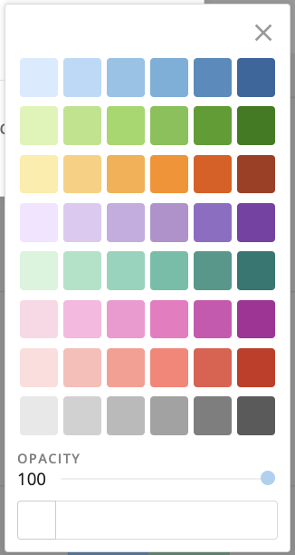

🎨 Palettes in Two Worlds — Old-School vs Modern Use

1. Color Palettes in Old WinAPI (Hardware-based)

These were a survival hack — not an aesthetic choice.

* **Context**: Back in the '90s, many monitors could only display 256 colors at a time.
* **Problem**: Images have thousands or millions of colors.
* **Solution**: Pick a *custom palette* of 256 best-fit colors for your app or image.
* **Complication**: Windows itself needed some of those colors too, so you’d *negotiate* with the system using functions like SelectPalette() and RealizePalette() to say, “Yo, I need these crayons for my image right now.”

If two programs had different palettes, the screen would literally **flicker or shift colors** when switching between them — called *palette flashing*.

So yeah, back then, palettes were a big deal. But now?

**👉 Not anymore. Modern systems use true color (millions of colors), so WinAPI palette functions are practically fossils — still in the API, but irrelevant unless you’re writing retro-style or embedded stuff.**

2. Design Palettes Today (HTML/CSS/UI Design)

These are about *style, consistency, and vibes* — not technical limits.

* **Context**: You can use millions of colors now.
* **Purpose**: You *choose* a limited set (a palette) for clarity, branding, and visual harmony — not because the screen forces you to.
* **Usage**: You pick colors like #222, #FFD700, etc., and reuse them throughout your app/site.

In this world, **palettes are for humans**, not hardware. And they’re very much alive and important.

🧠 Bottom Line



So when I said “they aren’t used much anymore,” I meant in the **technical hardware-managing sense** inside WinAPI — not the *concept* of palettes as a tool for design.

You're not crazy for thinking palettes matter — just need to know **which kind of palette** you’re dealing with.

PRINTING

While this chapter focuses on graphics display, most of the concepts covered can be applied to printing as well.

GDI provides a comprehensive set of functions for **controlling printing output,** allowing you to print text, graphics, and other visual elements with precision.

Printing-specific topics, such as printer drivers and page layout, will be discussed in more detail in Chapter 13.

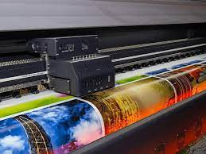

DEVICE CONTEXT

The **device context (DC)** is a fundamental concept in Windows GDI, acting as a bridge between your application and the graphics output device.

It **encapsulates the necessary information** and **attributes** for rendering graphics onto a specific device, such as the video display or a printer.

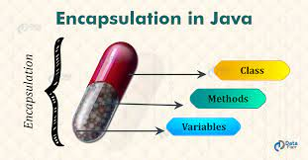

Imagine you're an artist. You’ve got your canvas (window), your paintbrush (pen), your roller (brush), and your box of crayons (palette). But here’s the twist — **you don’t get to just start drawing.**

First, you need to ask the Windows OS for **permission** — and it gives you a **magical sketchpad** called a **Device Context**.

🧠 So What *Is* a Device Context?

A **Device Context (DC)** is like your **art station** — a special workspace that Windows sets up for you when you want to draw on the screen, a printer, or even a hidden memory area.

When you get a DC, Windows hands you:

* 🎯 A **handle** (aka HDC) → your VIP pass to draw.
* 🖼️ Info about the **surface you're drawing on** (screen, printer, memory bitmap)
* 🧰 All your current **drawing tools** (pens, brushes, fonts, etc.)
* 🎯 **Where** and **how** you’re allowed to draw (clipping regions, transformations)

Think of it as your "drawing license" that also includes your gear, your canvas, and your permissions — all bundled in one.

✍️ Getting That Drawing License (How to Obtain a DC)

There are **different ways to grab a device context**, depending on what and where you're drawing. Here's how Windows gives you the keys:

1. BeginPaint / EndPaint

* Used inside the **WM_PAINT** message.
* Think of it like:

“Hey Windows, my window got damaged or needs repainting — give me a clean, valid DC to repaint just the messy part.”

* Automatically validates the area and tells Windows: "Don't call me again until it's messed up again."



✅ **Best for:** Redrawing parts of your window when Windows tells you to repaint.

2. GetDC / ReleaseDC

This is you saying:

“Yo Windows, I want to draw *right now* on my window — not just during WM_PAINT.”

You get access to the **client area only** (the inside rectangle of your window, not title bars or borders).



✅ **Best for:** Drawing spontaneously (e.g., when the user clicks, moves the mouse, or something happens outside WM_PAINT).

3. GetWindowDC / ReleaseDC

You say:

“Nah, I want *everything*, including borders, scrollbars, title bar — give me the whole window.”

You’re accessing the **entire window**, not just the client area.



✅ **Best for:** Custom-drawing title bars, overlays, skinned UIs.

⚠️ Rule of Thumb:  
If you grab a DC, **release it when you're done.** Otherwise, you get memory leaks and weird Windows behavior. (You don’t wanna be *that* dev.)

🎨 What’s Inside a Device Context?

The DC is like a toolbox + settings sheet + drawing zone. Here's what it stores:



Device Context Attributes

The device context holds a **collection of attributes** that determine how GDI functions operate on the target device. These attributes include:

* Font: Specifies the font to be used for text rendering.
* Text color: Defines the color of text drawn using GDI functions.
* Background color: Sets the color of the background area behind drawn text.
* Intercharacter spacing: Adjusts the spacing between characters in drawn text.
* Pen: Defines the characteristics of lines drawn using GDI functions, including line width, style, and color.
* Brush: Determines the appearance of filled areas, such as patterns or images.
* Clipping region: Defines the area within which drawing operations will be confined.

🧰 Changing the Tools (Modifying DC Attributes)

You don’t change a DC by saying "Hey bro, make the lines blue."  
You use **specific GDI functions** to update its tools:



🧠 Big Analogy to Lock This In

🎨 Think of a Device Context as your **drawing desk in an art studio**.

* **The desk (DC)** tells you where to draw (window, screen, printer)
* **The tools on the desk** (pen, brush, font) are what you're using
* **The canvas** (client area) is what you’re drawing on
* **The license (HDC handle)** gives you access — but if you forget to give it back, the studio gets mad (aka memory leaks)

You don’t draw on the wall directly. You ask for a desk, get your gear set up, and *then* make art.

Modifying Device Context Attributes

To modify device context attributes, you can use **specific GDI functions** that target each attribute.

For instance, **SetTextColor** changes the color of text drawn using GDI functions, while SetBkColor alters the background color.

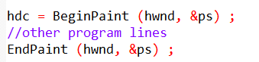

In this code, the **BeginPaint function** returns a device context handle to the variable hdc.

The **hwnd parameter** is the handle of the window for which you are obtaining the device context.

The **&ps** parameter is a pointer to a **PAINTSTRUCT structure**, which contains information about the painting operation, such as the invalid region of the window's client area.

The **[other program lines] section** is where you would put your drawing code.

Once you have finished drawing, you call the **EndPaint function** to release the device context handle.

The **hwnd parameter** is the same as the one you passed to BeginPaint, and the &ps parameter is the same pointer to the PAINTSTRUCT structure.

This is a common pattern for drawing in Windows applications. It ensures that your **application only draws in the invalid region** of the window, and that it releases the device context handle when it is no longer needed.

🧾 Final Thoughts on Device Contexts (DCs)

Before you run off drawing all over Windows like a graffiti artist in a pixel alley, here’s what you *really* need to know — the **must-remember notes** about how to treat your Device Context like a first-class citizen in your codebase.

🧠 The Big Picture:

The **Device Context (DC)** is your official backstage pass to draw on anything — whether it’s the screen, a printer, or a hidden image in memory. It’s not just a drawing tool, it’s the whole **workspace**, holding:

* What you’re drawing **on** (the canvas/surface),
* What you’re drawing **with** (pen, brush, font, etc.),
* And **how** you’re allowed to draw (clip region, transformations, etc.).

You get one by calling functions like:

* BeginPaint() – Used inside WM_PAINT, handles screen refreshes.
* GetDC() – Grabs the client area any time.
* GetWindowDC() – Gives you the entire window, including borders and UI.
* GetDCEx() – Power move. Use this for advanced control (e.g. drawing with clipping flags or outside WM_PAINT rules).

🚨 Best Practices: Treat Your DC Like Gold

* 🧼 **Always release it**: If you grab a DC manually (GetDC, GetWindowDC), **release it** with ReleaseDC() when you're done. Think of it like borrowing someone’s pen — don't walk off with it.
* 🧠 **Inside a message handler?** Then release the DC **before** your window procedure exits. Keep things clean, or you’ll leak GDI objects like a busted faucet.
* 🧰 **Customize it carefully**: Use functions like SelectObject(), SetTextColor(), SetBkColor(), etc. to update what your DC draws and how.
* 📚 **Still confused?** Microsoft’s docs go deep — bookmark them as your GDI Bible for when you level up.

💡 TLDR for Beginners (The Recap Cheat Sheet)

* **DC = Drawing license + canvas + tools + rules.**
* Use BeginPaint, GetDC, or GetWindowDC to get one.
* Use it to draw text, shapes, images, etc.

NB:



Here is an example of how to obtain a device context handle for the client area of a window using **BeginPaint** and **EndPaint**:

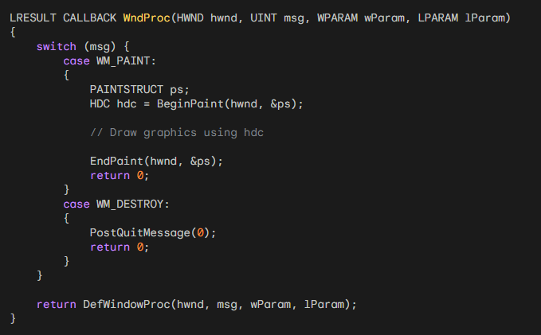

Here is an example of how to obtain a device context handle for the entire window using **GetDC** and **ReleaseDC**:

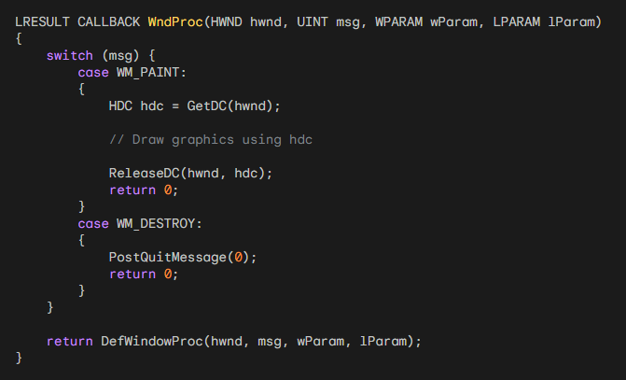

**GetWindowDC:** This function is used to obtain a device context handle for the entire window, including the non-client area. It is similar to GetDC, but it is less commonly used.

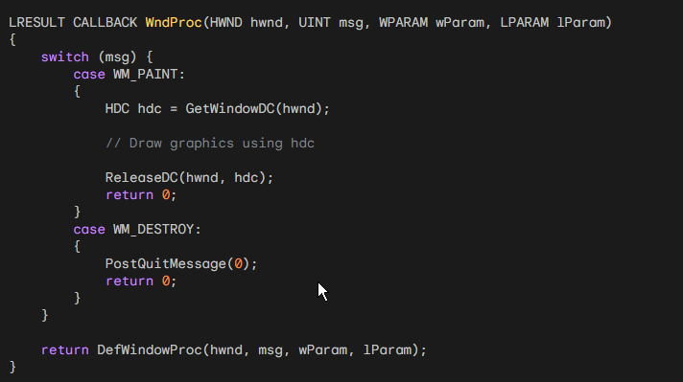

**CreateDC:** This function is used to obtain a device context handle for a specific device, such as the display or a printer. The CreateDC function returns a handle to the device context, and the DeleteDC function releases the handle.

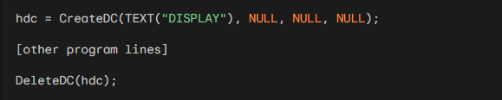

**🕵️‍♂️ CreateIC — The Read-Only Device Spy**

Think of CreateIC as you saying:

“Hey Windows, I don’t want to draw anything right now — I just want to **look at the specs** of a device (like a printer or display) to learn what it’s capable of.”

It gives you a special handle called an **information context** — it’s like holding a clipboard with **device info only**.

* ❌ You **can’t use it to draw** anything.
* ✅ You **can use it to ask questions** like:
  + "What’s the DPI of this printer?"
  + "How many colors can this screen display?"
  + "What fonts are supported?"

Once you're done peeking at the device stats, you close the clipboard using DeleteDC().



**🧾** CreateIC gives you a *read-only connection* to a graphics device.

It’s for **gathering info**, *not* for drawing. Use DeleteDC() when you're done.

**🧠 CreateCompatibleDC: For Offscreen Drawing**

This one creates a *memory device context* — basically an invisible canvas in RAM.

* *It returns a handle to a DC that’s compatible with a given screen or printer*
* *You can select a bitmap into this DC using SelectObject()*
* *Then use GDI functions like TextOut, BitBlt, etc., to draw offscreen*
* *When done, release it with DeleteDC()*

💡 Great for **double-buffering**, image generation, or drawing without flickering on screen.

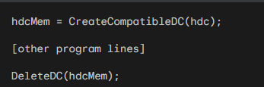

**🎞️ CreateMetaFile: For Recording, Not Drawing**

This function gives you a *metafile device context* — think of it like a recorder.

* *It returns a handle to a metafile DC (device context)*
* *You can’t draw directly on this handle*
* *You use it to record GDI drawing commands*
* *Once you're done recording, call CloseMetaFile() to finish and save it as a .WMF (Windows Metafile)*

💡 Use when you want to **record** GDI operations for later playback — not for live drawing.

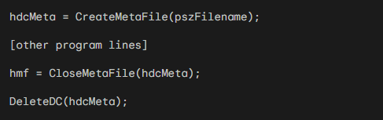

Creating a Device Context for the Entire Display

You can obtain a device context handle for the entire display by calling CreateDC with the following parameters:

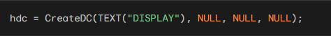

This specific function call tells Windows, **"Give me a drawing handle (hdc) for the entire display. “**

If you get this handle, you could **theoretically draw anywhere** on the screen, even outside your application's own window. Imagine drawing directly on top of another application or your desktop icons.

While technically possible, it's **almost never a good idea** for a typical application to draw directly on the entire screen.

**NB:**

*Such a feature might only be used by specialized applications like screen recorders, screen sharing tools, or very low-level utilities that need to capture or manipulate the entire display, like malware*🤣*Memez virus, right?*

Creating an Information Context

Sometimes you need only to obtain some information about a device context and not do any drawing.

In these cases, you can obtain a handle to an **"information context"** by using CreateIC.

The arguments are the same as for the CreateDC function. For example:



You can't write to the device by using this information context handle.

Creating a Memory Device Context

When working with bitmaps, it can sometimes be useful to obtain a "memory device context".

A **memory device context** is a device context that resides in memory rather than on a physical device.

This can be **useful for storing** and **manipulating bitmaps** without having to write them directly to the display.

To create a memory device context, you can call **CreateCompatibleDC** with a handle to another device context as an argument. For example:



You can then **select a bitmap into the memory device context** and use GDI functions to draw on the bitmap.

Creating a Metafile Device Context

A **metafile** is a collection of GDI function calls encoded in binary form.

You can create a metafile by obtaining a **metafile device context.**

To create a metafile device context, you can call **CreateMetaFile** with the name of the metafile as an argument. For example:



During the time the metafile device context is valid, any GDI calls you make using **hdcMeta** are not displayed but become part of the metafile.

When you call **CloseMetaFile**, the device context handle becomes invalid. The function returns a handle to the metafile (**hmf**).

Releasing Device Context Handles

When you are finished using a device context handle, you should **always release it.**

This will **free up the resources** associated with the handle and make it available for other applications to use.

To release a device context handle, you can use the **DeleteDC** function. For example:

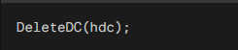

You can also release a device context handle that was obtained with GetDC or GetWindowDC by calling ReleaseDC. For example:

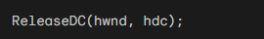

Obtaining Device Context Information

The **GetDeviceCaps function** is used to retrieve information about a device context.

The function takes two arguments: a **handle** to a device context and an **index** that specifies the information to retrieve.

The function **returns the requested information** as an **integer** value.

🧾 Getting Info from a Device Context — GetDeviceCaps()

Once you've got a device context (DC), you might want to know stuff about the device it's connected to — like:

* *How big is the screen in pixels?*
* *What’s the DPI (dots per inch)?*
* *How many colors does this thing support?*

That’s where **GetDeviceCaps()** comes in.

🛠️ How it Works



* **hdc** = The device context handle (from GetDC, CreateIC, etc.)
* **INDEX** = What kind of info you want (like width, height, DPI, etc.)
* It **returns** the answer as an int.

🧠 Analogy Time:

Think of the device context (DC) as a detective at a crime scene (the device).  
GetDeviceCaps() is you **asking the detective questions** like:

* "How wide is the display?"
* "How many colors does this suspect support?"
* "What’s the DPI of this shady printer?"

And the detective just responds with numbers. 😎

🧾 Example:



🔍 Common GetDeviceCaps Indexes: Commonly Used Device Context Information



Example Code

The following code snippet retrieves the width of the video display in pixels:

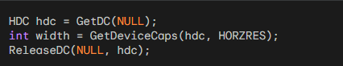

The following code snippet retrieves the vertical resolution of the printer in pixels per inch:

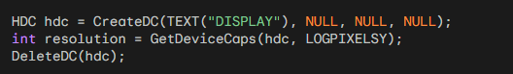

The **GetDeviceCaps function** is used to retrieve information about a specific device context.

If you want to retrieve information about the system as a whole, you can use the **GetSystemMetrics function.**

The GetDeviceCaps function *returns an integer value*, which may need to be converted to a more meaningful unit of measurement (e.g., millimeters, inches).

For more information on the GetDeviceCaps function, please refer to the Microsoft Windows documentation.

DEVCAPS1 PROGRAM

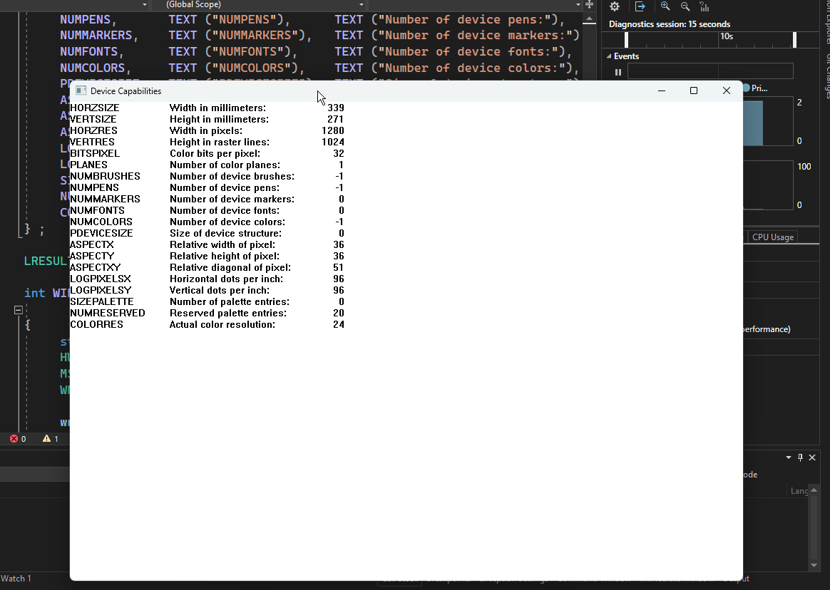

Code in chapter 5 folder.

📺 DEVCAPS1 – Intro

This simple app uses GetDeviceCaps to display hardware info about the current display device — like screen resolution, number of colors, and DPI.

It follows the standard WinAPI layout:

* **WinMain:** Registers the window class, creates the main window, runs the message loop.
* **WndProc:** Handles WM_CREATE (for setup) and WM_PAINT (to draw the device capability list).

🧠 No surprises here:

You’ve already covered all this (WinMain, CreateWindow, message loop, etc.) in previous notes — so we’ll skip the repetition and focus only on the **new concept**:

→ **GetDeviceCaps** + how it’s used to pull real display metrics from the device context.

THE SIZE OF THE DEVICE

🧱 Understanding Device Size, Resolution & Aspect Ratios (for GDI & Windows Apps)

When you're building a Windows app, you're not just drawing into the void.

You're targeting a real physical screen (or a printer, or a memory bitmap).

So you *have to* think about how big that surface actually is — in pixels **and** in physical dimensions like inches or millimeters.

🔢 Pixel Dimensions vs. Real-World Size

* **Pixel Dimensions** = Total number of pixels horizontally and vertically.  
  Example: 1920x1080 means 1920 columns and 1080 rows of pixels. (rows: r to left)
* **Metrical Dimensions** = The actual **physical** size of the display area, measured in **inches** or **millimeters**.  
  (You can grab this info using GetDeviceCaps() with HORZSIZE and VERTSIZE.)

**🔍 Why does this matter?** Two displays might have the *same resolution* but be physically very different in size — like a 15" laptop vs. a 27" monitor. That’s why text or UI can look huge on one screen and tiny on another.

🖼️ Resolution: Pixels Per Inch (PPI)

**Resolution** is a measure of how many pixels are contained in a given area of a display. The resolution of a device is typically given as the number of **pixels per inch (PPI).**

It’s how many pixels fit into a single inch — often called PPI or DPI (Dots Per Inch).

You can calculate it using this formula:



The higher the DPI, the *sharper* everything looks — but your layouts need to scale accordingly!

🔲 Square vs. Non-Square Pixels (Yup, it was a thing)

* **Today**: Most modern displays use **square pixels**, meaning each pixel is the same height and width.
* **Back in the day**: Some old displays had **non-square pixels**, which made circles look like ovals unless you compensated for the pixel shape.

**💡 Why you should care:** If you draw based only on pixels, and assume everything is square, things may appear distorted on non-standard hardware (still relevant in embedded or custom setups!).

📐 Aspect Ratio: Width vs. Height

Aspect ratio is simply the proportional relationship between the width and the height of a screen or image. It's always expressed as **Width : Height.**

Example: 4:3 (old CRTs), 16:9 (modern widescreens), 3:2, 21:9 (ultrawide), etc.

The numbers (e.g., 4:3, 16:9) are **not measurements** in inches, pixels, or any specific unit. Instead, they represent a *ratio* of "parts" or "units."

It means that **for every 'X' units of width, there are 'Y' units of height.** These units can be anything – pixels, inches, centimeters, or just abstract "parts."

* *The actual size of the screen doesn't change the aspect ratio, only its dimensions in those ratio units.*
* *You should never hardcode for a specific aspect ratio.*

✅ **Instead**: Use **GetDeviceCaps()** or APIs like **GetSystemMetrics()** to query actual screen dimensions, and **adapt**.



Example: 4:3 This means that for every 4 units of width, there are 3 units of height. If a screen is 4 inches wide, it would be 3 inches high. If it's 400 pixels wide, it's 300 pixels high. This was the standard for old CRT (Cathode Ray Tube) televisions and early computer monitors, giving them a more "squarish" look.

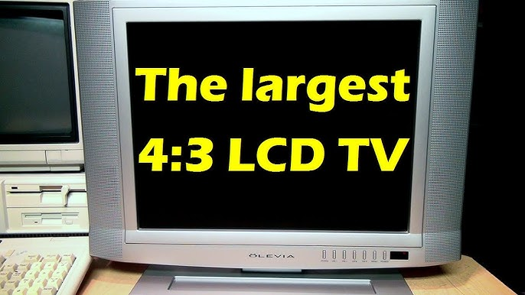

Example: 16:9 This means for every 16 units of width, there are 9 units of height. This is the modern standard for most widescreen TVs, computer monitors, and high-definition video (like YouTube and streaming services). It's much wider than it is tall.

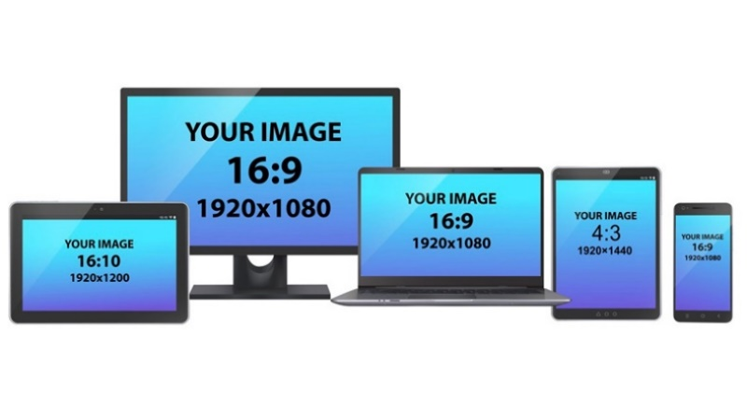

My PC: 1650 x 1050 Resolution

To find the aspect ratio of your 1650 x 1050 screen, you need to simplify the ratio of its width to its height by finding the greatest common divisor (GCD) of both numbers.

* *Start with the resolution: 1650 (width) : 1050 (height)*
* *Find the Greatest Common Divisor (GCD).*
* *Both numbers end in 0, so they're divisible by 10: 165 : 105*
* *Both numbers end in 5, so they're divisible by 5: (165 / 5) : (105 / 5) = 33 : 21*
* *Both numbers are divisible by 3: (33 / 3) : (21 / 3) = 11 : 7*
* *Therefore, your PC's resolution of 1650 x 1050 has an 11:7 aspect ratio.*

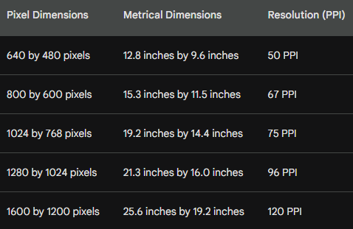

💥 Beginner Mistake Warning

**Wrong**: You hardcode your UI thinking everyone has a 1920x1080 screen.

**Right**: You ask the system for the actual screen size, then dynamically lay things out.

🧠 TLDR – What Should You Remember?

* Use **GetDeviceCaps()** to query resolution, DPI, and screen size.
* Don’t assume every screen is 1920x1080 or has square pixels.
* Always adapt layout based on the **actual screen size and DPI**.
* Don’t hardcode for 4:3, 16:9 — aspect ratios can vary **wildly**.

🧠 Resolution: What It *Really* Means (And How the Term Got Hijacked)

🎯 1. How to Check Your Screen’s Pixel Size (as a regular user)

Want to see how many pixels your monitor is made of? Simple:

* Open **Control Panel** → **Display Settings**
* Go to the **Settings** tab (or in Windows 10+, it's called **Display → Scale and Layout**)
* There you’ll see something like:  
  👉 1920 x 1080 (Recommended)

✅ That number is your **screen resolution in pixel dimensions** — it means the screen is 1920 pixels wide and 1080 pixels tall.

📏 2. The Two Meanings of Resolution (Don't Mix 'em Up)

Here’s where it gets tricky. The word **resolution** is often used **in two completely different ways**, especially in graphics programming:

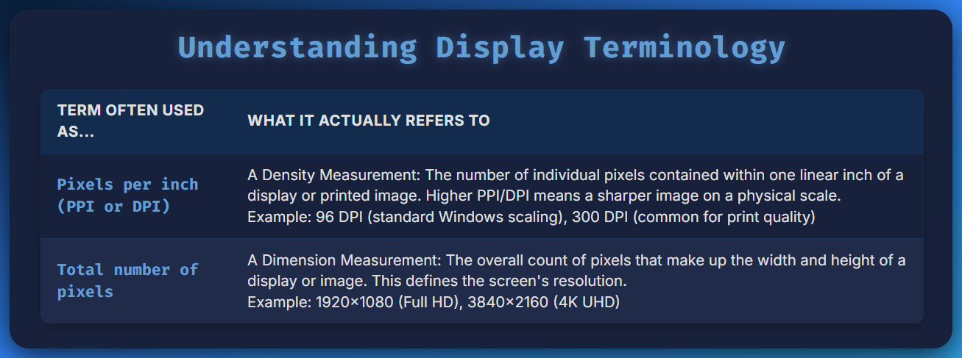

🤯 So Wait… What’s the Difference?

* **DPI (Dots Per Inch)** = How tightly packed the pixels are. A 1920x1080 screen at 96 DPI is *much bigger* physically than a 1920x1080 screen at 144 DPI.
* **Resolution (1920x1080)** = Just how many pixels wide and tall the display is — *not* how dense they are.

💡 Think of it like this:

* **DPI** = How sharp the crayon tip is.
* **1920x1080** = How big your coloring book is in squares.

📺 Most Monitors Today…

* Are marketed by **pixel dimensions** ("1080p", "4K", "1440p", etc.)
* Are still mostly around **96–144 DPI**, unless they’re high-end or Retina-like displays

And yeah — “**resolution**” today often just means **pixel count**, not DPI. Which is fine in daily life, but in **graphics programming**, it’s important to know the *real meaning*.

🧠 TLDR

* DPI = Pixel density (pixels per inch) → True resolution.
* 1920x1080 = Pixel dimensions → What people *call* resolution today.
* Use GetDeviceCaps(hdc, LOGPIXELSX/Y) for DPI.
* Use GetDeviceCaps(hdc, HORZRES/VERTRES) for pixel dimensions.

**📏** Pixel Dimensions vs. Physical Dimensions: What’s the Deal?

When you're coding in WinAPI (or any desktop graphics stuff), you can ask Windows:

* “How many pixels is this screen?” → That’s **resolution in pixels**
* “How physically wide/tall is this screen?” → That’s **size in millimeters**

Seems straightforward, right? But... there's a plot twist.

🔹 Two Ways to Get Pixel Dimensions

You can get screen dimensions in pixels from **two different functions**:

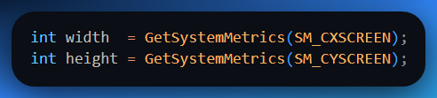

OR

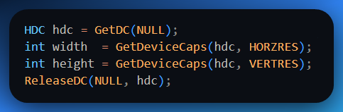

Both give you the **same thing**: total width and height of the screen in pixels.

✅ Use whichever is easier in your situation. GetSystemMetrics() is simpler (no DC needed), while GetDeviceCaps() gives more advanced metrics.

🔸 Physical Dimensions (HORZSIZE and VERTSIZE)

Now here’s where beginners get tripped up. Windows also lets you query the **physical size of the display**, like this:

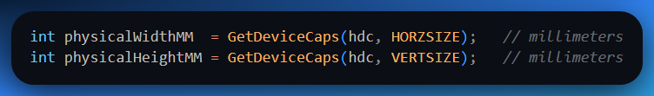

This is supposed to tell you:

“Hey! The screen is **X mm wide** and **Y mm tall**.”

But how does it actually know that?

❓How Does Windows Know the Actual Monitor Size?

🧠 Reality check: Most monitors don’t tell Windows their **real physical size**.

**💻 What might happen:**

* **Laptop screen?** The built-in driver *might* know.
* **External monitor?** Only if the monitor sends accurate data via **EDID** (Extended Display Identification Data).
* **Old projector or janky HDMI adapter?** Windows has no clue — it just fakes a number.

So in practice:

**HORZSIZE** and **VERTSIZE** are **often guessed or calculated**, not guaranteed to be accurate.

🤓 Behind the Scenes: How Windows Calculates HORZSIZE

If the monitor doesn't report physical dimensions, Windows estimates it like this:

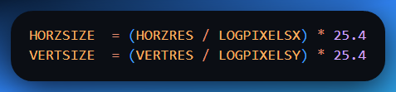

💡 Why 25.4? Because that’s how many **millimeters are in one inch**.

So it's basically saying:

*“If I know the screen is 1920 pixels wide, and each inch holds 96 pixels, then the screen must be about 20 inches wide. Let me convert that to millimeters for you.”*

📐 Example:

Let’s say:

* Screen resolution = 1920 x 1080
* DPI (LOGPIXELSX/LOGPIXELSY) = 96

So Windows will *estimate* the screen is about **508mm x 285mm**.

🛑 But Wait — Why Does This Matter?

Because if you're doing **layout based on physical units** (e.g., printing, DPI-aware drawing, inch-based measurements), you need to **know whether you're dealing with reality or an illusion**.

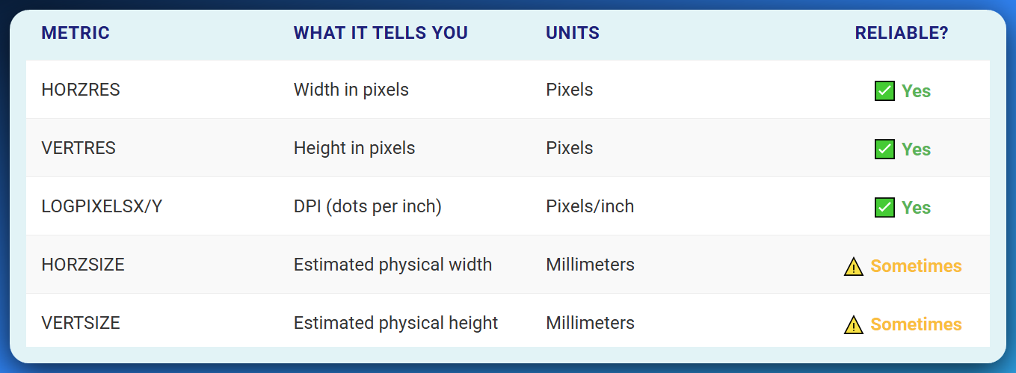

**🖥️** Display Applet, Fonts, and Why It All Feels Off Sometimes

You ever change your screen resolution and suddenly the text looks like it shrunk into a wormhole?

That’s because increasing resolution doesn’t automatically scale up the **system font size**.

Back in the day, Windows gave you a choice: **Small Fonts** or **Large Fonts** — kind of like saying:

*“Yo, you're on a 1024×768 screen now? Wanna boost those UI fonts so your grandma can still read your menus?”*

This was set via the **Display applet** in Control Panel, under the **Settings** tab (pre-Windows 10 era). You’d pick:

* 🐜 Small Fonts — designed for 640x480 and low-res screens.
* 🐘 Large Fonts — better suited for high-res setups like 1024x768 and above.

Nowadays, this idea evolved into **DPI scaling** (like 100%, 125%, 150%) — but it started here.

✒️ Point Size: Fonts in the World of Typography

Let’s pause and go to the world of print.

**Typography 101**:

* **1 point = 1/72 of an inch**
* So a **12-point font** should be about **1/6 of an inch tall**

🔤 But what does "tall" mean?

Font height *should* cover:

* The tallest letter (like **H** or **T**)
* Down to the **descenders** (the dangly bits of **p**, **q**, **y**, etc.)
* ⚠️ Not including accent marks (like é, ñ)

So in theory:

A **10pt font** should take up **10/72 of an inch** from the top of the tallest letter to the bottom of the longest descender.

🧱 Enter WinAPI: How Does Windows Know Font Size?

Windows gives you a TEXTMETRIC structure — a bundle of info about any font you select. It has fields like:

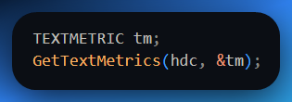

Here’s what matters:

* tmHeight - Total height of the font (from top to bottom).
* tmInternalLeading - Space inside the font between lines (think: built-in line padding).

And here's the key:

**Point size ≈ tmHeight - tmInternalLeading**

Why? Because that gives you the **actual height of the glyphs**, not the extra breathing room around them.

📏 Real-World Typographer Secrets

Here’s the fun part: **Font designers cheat.**

**Not all 12-point fonts are the same physical height.** Some will appear slightly taller or shorter, even at the same point size. This is for aesthetic reasons — tighter, cleaner, or more dramatic appearances. So don’t assume “12pt” means exact physical size on every font. It’s more like a *guideline*.

📐 Line Spacing (Leading)

When you're arranging text, **line spacing (also known as leading)** is crucial. It's the vertical distance from the bottom of one line of text (its "baseline") to the bottom of the next line's baseline.

Think of tmHeight as giving you a good starting point for how far apart your lines should be.

✍️ Rule of Thumb for Readability:

Avoid making your line spacing *exactly* the same as your font's point size. If you do, the tops of letters on one line might crash into the bottoms of letters on the line above, making it hard to read.

**Example:**

* If your font size is 10pt.
* Your line spacing should ideally be at least 12pt or even more to ensure good readability.

This is why programs like Microsoft Word or professional typesetting software often use terms like "line spacing: 1.2x" (meaning 1.2 times the font size) or "14pt on 12pt text" (meaning 14pt line spacing for 12pt font size). They're all about giving your text enough room to breathe!

🧠 Summary for Beginners

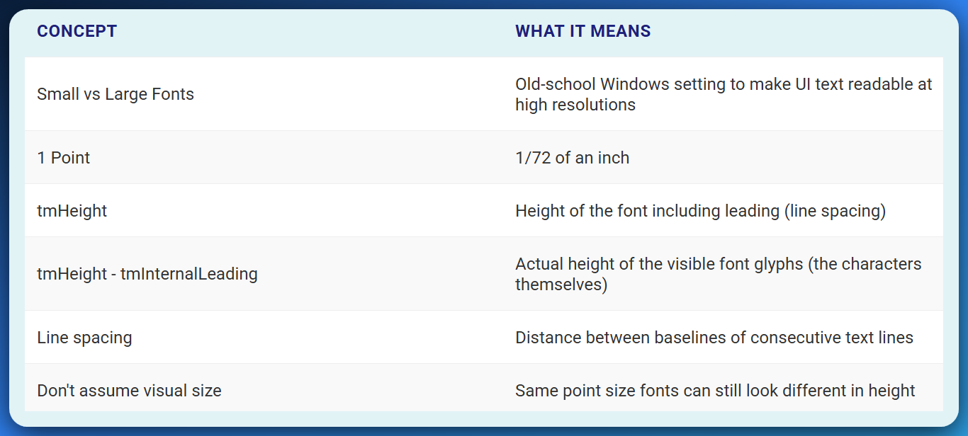

🖋️ The Windows System Font: “Wait... Both Fonts Are 10pt?”

Yeah. That’s not a typo.  
Whether you select **Small Fonts** or **Large Fonts** in the old-school Display settings, **Windows still uses a 10-point font**.

But here's the twist:  
The *same* 10pt font will **look bigger or smaller on your screen** depending on one thing...

👉 **Your screen’s DPI setting (Dots Per Inch)**.

🧠 Wait — What’s DPI?

Think of DPI like this:

DPI is like how tightly your printer or screen can *pack ink dots* (or pixels) into an inch.

* **96 DPI** = normal screen density (default for most Windows settings)
* **120 DPI** = more dots in an inch = everything looks **larger** (without increasing resolution)

Now here’s the catch...

When you switch between Small Fonts and Large Fonts, **you’re not changing the font size** *.... You’re changing how many dots Windows thinks fit into an inch.*

🚀 Small Fonts vs. Large Fonts

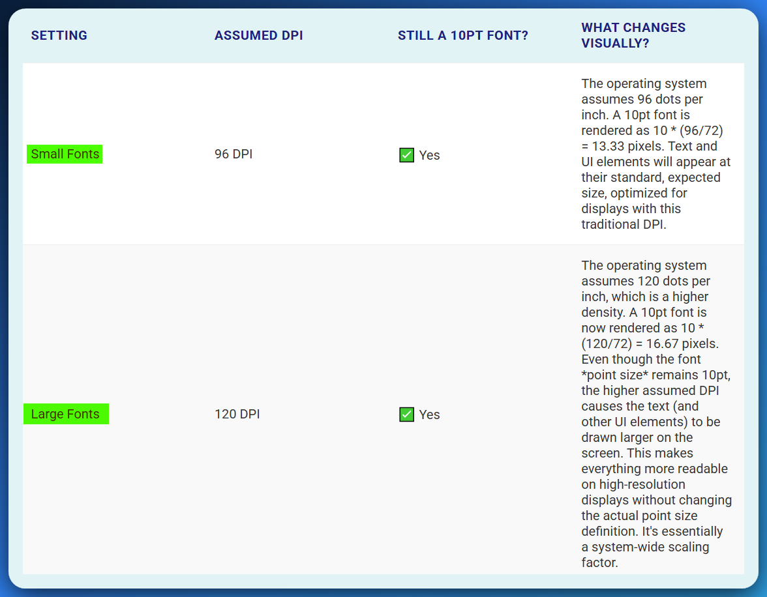

Even though the point size is fixed at 10pt:

* At **96 DPI**, Windows fits more pixels in each inch, so the font appears normal.
* At **120 DPI**, Windows spreads out the font more per inch → it **looks larger**, even though it’s still 10pt.

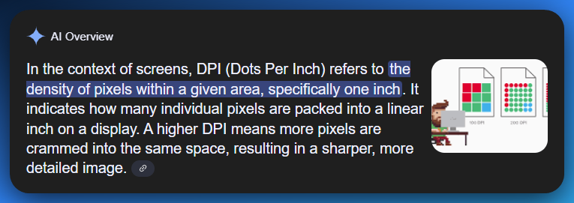

🧮 Font Size + Line Spacing in Pixels

Here's where tmHeight from the TEXTMETRIC struct enters the scene.

**1. Small Font (96 DPI)**

* 12-point line spacing × 96 DPI ÷ 72 = **16 pixels**
* This is your vertical space between lines (aka tmHeight)

**2. Large Font (120 DPI)**

* 12-point line spacing × 120 DPI ÷ 72 = **20 pixels**
* Same font, but now more pixel space → visually looks larger and more readable

Even though you pick a 10pt font, it might **look** like 11pt or more. That’s **intentional**.

👉 *Font designers often make characters slightly taller to improve readability — especially on lower-DPI displays.*

So the font **metrics** may say “10pt,” but the **visible glyph height** can be slightly larger than expected. That’s typographic design at work.

📦 Summary TLDR (for Beginners)

**Small vs. Large Fonts** aren’t different fonts — they both use a **10pt system font.**

* The difference is in the **assumed DPI** setting:
  + Small = 96 DPI → standard spacing.
  + Large = 120 DPI → more space per inch → font *looks* bigger.
* The line spacing is still **12pt**, but in pixels:
  + 96 DPI → 16px.
  + 120 DPI → 20px.
* tmHeight in WinAPI tells you the **total line height** in pixels.

Font visuals aren’t always literal — designers tweak actual height for aesthetics and legibility.

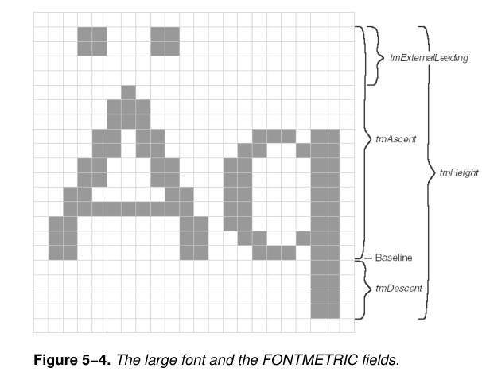

UNDERSTANDING DEVICE CAPABILITIES

In Windows graphics programming, "device capabilities" tell you what your output device (like your screen or printer) is capable of.

Think of them as the **"stats" of your hardware** — like the health bar of your graphics device. You can retrieve these stats using the GetDeviceCaps() function.

Device capabilities are a set of values that provide information about the hardware and software capabilities of a computer system.

These capabilities can be retrieved using the GetDeviceCaps function in Windows applications.

🎯 Logical Pixels vs. Physical Pixels (DPI vs. Real Size)

Let’s imagine you’re designing an app window.

Your instinct says:

“This rectangle should be 100 pixels wide — that should look the same on any screen, right?”

❌ **Wrong** — because **100 pixels** looks **tiny on a 4K screen** and **huge on a low-res projector**.

Why?  
Because *a pixel isn't always the same size in the real world*. That’s where **logical pixels** come in.

🧱 Physical Pixels = Actual Dots on the Screen

Think of these as the **grains of sand** that make up your screen.

**🧮 Logical Pixels = DPI-based virtual measurement**

These are **adjusted based on user preference or Windows scaling settings**, so everything *looks the same size* across different devices.

Think of logical pixels as using a **"zoom level"** so your font doesn't look microscopic on high-res displays.

📏 LOGPIXELSX and LOGPIXELSY

These give you the **DPI** — **dots per inch** — horizontally and vertically.

DPI = How many pixels are squished into one inch.

* 96 DPI = normal density (1 logical pixel = 1 actual pixel)
* 120 DPI = zoomed-in mode (bigger fonts & UI)
* 144 DPI or more = high scaling (used for 4K, big displays)

📐 HORZSIZE and VERTSIZE

These give you the *physical size of the screen in millimeters*.  
But don’t get it twisted: **Windows often has to *assume* this size.**

You might think:

“But my monitor is 27 inches... shouldn’t Windows know that?”

Not really. It doesn't always know your screen's actual size because most monitors **don't report it directly**.

So what does Windows do?

🧮 Windows *Calculates* the Size

Here’s how:

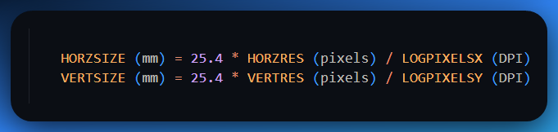

**25.4 mm = 1 inch**, so this formula just converts pixels per inch into physical dimensions.

👉 Bottom line: Windows *estimates* your screen’s physical size based on resolution and DPI.

🔁 Why Use Logical Resolution?

Imagine two people both using a 10-point font:

* One on a tiny laptop screen
* One on a huge projector

Without scaling (logical DPI), that font would look *tiny* on the projector and *gigantic* on the laptop.

📏 **Logical resolution** makes sure fonts and UI elements appear **consistently sized across all screens**. It's how Windows says: “10-point font should always *look like* a 10-point font — no matter the screen.”

🧪 Real-World Example

Let’s say:

* Your screen is 1920 × 1080 (HORZRES / VERTRES)
* Your DPI is 96 (LOGPIXELSX / LOGPIXELSY)

Then:

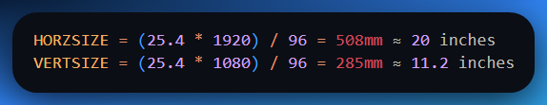

That’s how Windows **estimates** the physical dimensions of your screen.  
Even if it doesn’t have exact hardware info, it can *guess* the size well enough to make scaling decisions.

🧵 What Happens When Resolution Is Too Low?

Let’s say you have:

* A 17" monitor
* And you’re running Windows at 640×480 (yikes)

That’s only **53 DPI**.  
If you render a 10-point font (≈ 13 pixels), it’ll be *tiny and unreadable*.

That’s why modern systems:

* Increase resolution (more pixels)
* Use **scaling** (logical DPI)
* Let you adjust font sizes in Display Settings

🧠 Tip: Always **query these values in WinAPI** — never hardcode assumptions about screen size or DPI. Your app might look fine on your monitor but broken on someone else's 4K ultrawide.



🧠 The Role of the 10-Point Font

Think of the **10-point font** like the “golden standard” in text size.

* It's readable in books.
* It's what your teachers used in school reports.
* If you can read it in print, it *should* be readable on screen.

But here’s the trick — for that to work on different screens, **Windows has to *translate* that 10-point idea into pixels**, and that’s where all the DPI and screen-size trickery begins.

🖥️ How Windows 98 Handles It

**🛠️ Formula Style**

Windows 98 says:

*“Let’s use the screen’s actual pixel resolution and the logical DPI (dots per inch) to calculate how big stuff like fonts should look.”*

So if:

* Your screen is 1920x1080 pixels, and
* The DPI is 96 (standard),
* Then a 10-point font = **13 pixels tall** (more or less, depending on font design).

This approach is pretty fair:  
It scales fonts and UI stuff based on **actual screen details + your preferences**.

**Pro**: Responsive and flexible.  
**Con**: Slightly less predictable on old or weird monitors.

💾 How Windows NT Did It

Windows NT? Different story. NT said:

*"Let’s just pretend the screen is a fixed size, no matter what."*

So HORZSIZE and VERTSIZE (which are supposed to represent the screen’s physical size in mm) are **hardcoded to standard values** like:

* 270 mm wide
* 203 mm high

Even if your actual screen is way bigger or smaller!

**Why?**  
This made things more predictable in enterprise environments. It kept old apps happy — apps that assumed your monitor was “standard size.”

⚠️ So What Happens?

If you’re developing an app using GDI and ask Windows:

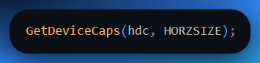

Depending on your OS (Win98 vs NT/XP/Win11), you might get:

* An actual calculated value based on pixels and DPI (good!)
* Or a hardcoded "pretend monitor size" (maybe not so good!)

This is why sometimes your fonts look **tiny on 4K monitors** or **huge on projectors** — it’s the DPI translation game at work.

🧪 Real Problem: Mixed Signals

Let’s say you use these GDI calls:

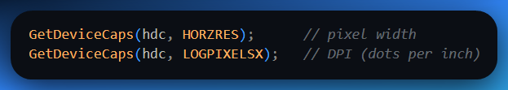

Then you plug those into this formula:



On Windows 98 → You’ll get something **close to your actual screen width**.  
On NT-based systems → You might get that fake 270 mm even if you’re on a 43" TV.

📏 Want the Real Monitor Size?

Windows itself can’t reliably tell unless the monitor supports **EDID** (Extended Display Identification Data) *and* the driver is cooperating.

So if your app **must** know the real physical screen size?  
👉 **Ask the user** in a dialog box.

*"Please enter the diagonal size of your monitor in inches"*

or

*"What is your screen’s width in millimeters?"*

Might feel old-school, but it’s the most foolproof method.

🧃 TLDR Summary

* The **10-point font** is a baseline for readability, but translating that into pixels requires DPI math.
* **Windows 98** used a dynamic formula based on actual screen info.
* **Windows NT** used a fixed fake size to maintain compatibility.
* Different methods = potential inconsistencies in how apps render text and graphics.
* If you want **accurate** physical screen size, don’t trust Windows — just ask the user.

ASPECTX, ASPECTY, and ASPECTXY

The ASPECTX, ASPECTY, and ASPECTXY device capabilities provide information about the relative width, height, and diagonal size of each pixel.

These values are relevant for applications that need to account for the aspect ratio of the display, such as video playback or image processing.

Imagine each pixel on your screen isn’t a perfect square (though most are these days). Instead, think of it like a **tiny tile** — and sometimes, those tiles might be slightly **wider** or **taller** than they are square.

That’s where these values come in:

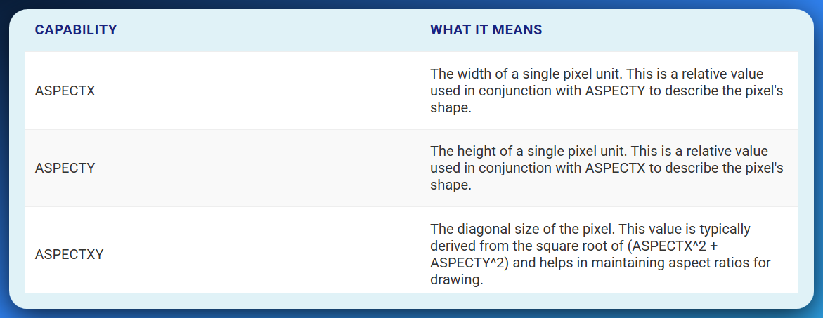

These are measured in “device units per millimeter” and help your program understand how stretched or squished a pixel might be.

Why should you care?

🎥 In video playback or image editing, if you *assume* every pixel is a perfect square and it's not, your circles turn into ovals. Your faces get warped. It’s like watching YouTube on a CRT — weirdly stretched.

🎨 Color Depth & Bits Per Pixel — How Deep Is Your Color?

This is where things get juicy.

Every pixel on your screen is just a bunch of bits. And the more bits you give a pixel, the more colors it can show. Let’s visualize:

**🧮 The Cheat Sheet**

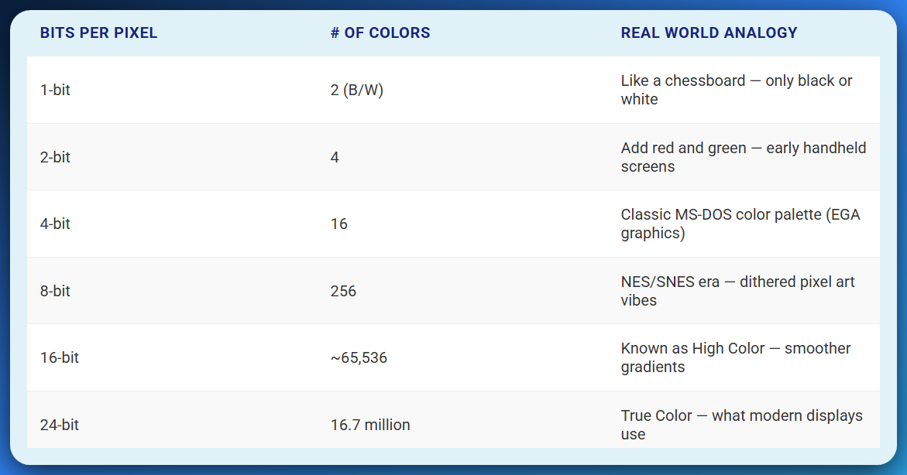

Each “bit” adds exponential power to your ability to represent color. 24-bit is:

* 8 bits for Red
* 8 bits for Green
* 8 bits for Blue  
  (256 shades per channel = 256 × 256 × 256 = **16,777,216 colors**)

That's more colors than the human eye can even distinguish — wild, right?

💾 Where WinAPI Fits In

When you call GetDeviceCaps(hdc, BITSPIXEL), Windows tells you how many bits are used **per pixel**. This is **vital** if your program is dealing with:

* **Image rendering**
* **Screenshots**
* **Custom drawing**
* **Low-level graphics like DIBs (Device Independent Bitmaps)**

For example:

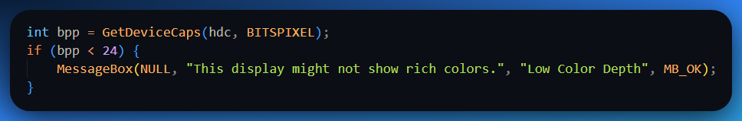

This helps you write adaptive programs — if the user’s display is in 16-bit or 8-bit mode, maybe you reduce image quality or warn them.

🧠 Analogy for Beginners: Pixels Are Like Paint Buckets

Each pixel is like a **bucket** that can hold color.

* A **1-bit pixel** is a bucket that holds **just black or white paint**.
* A **4-bit pixel** is a bucket that holds **16 preset paint options**.
* A **24-bit pixel** is like a **magic bucket** — mix **any** R, G, and B paint in billions of combos.

And ASPECTX, ASPECTY, ASPECTXY? That tells you whether your buckets are **square**, **flattened**, or **tall and skinny**. Because you can’t paint properly if you don’t know the shape of your canvas.

⚙️ TLDR (Cheat Mode Recap)

* ASPECTX, ASPECTY, ASPECTXY = Describes **pixel shape**, useful for precise layouts & image rendering.
* **Color Depth / Bits per Pixel** = Tells you how many colors your display can show.
* BITSPIXEL = The WinAPI call to get this value.
* Color depth, also known as bits per pixel (bpp), refers to the number of bits used to represent the color of each pixel on a video display.
* Modern displays use **24-bit True Color** (16.7M colors), but your program should still **check** for older setups (especially in VMs or remote desktops).

A higher color depth allows for a wider range of colors to be displayed, resulting in more vibrant and realistic images.

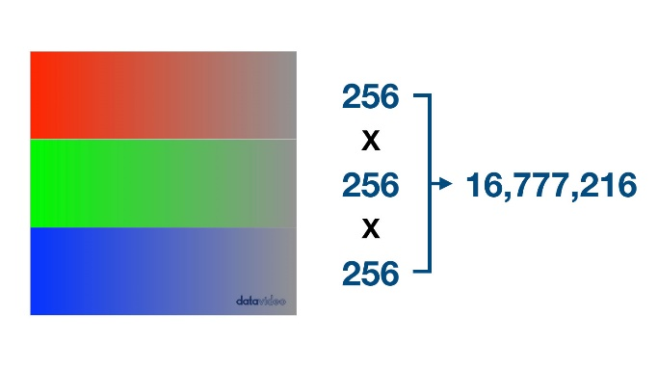

Common Color Depth Values

**1-bit color:** This is the simplest form of color display, capable of displaying only black and white pixels. It requires one bit per pixel.

**2-bit color:** This color depth allows for four unique colors: black, white, red, and green. It requires two bits per pixel.

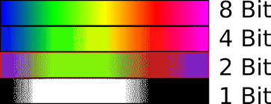

**4-bit color:** This color depth allows for 16 unique colors, typically a combination of black, white, red, green, blue, yellow, cyan, and magenta. It requires four bits per pixel.

**8-bit color (High Color):** This color depth, also known as 256 colors, allows for 256 unique colors. It is commonly used for basic graphics and video playback. It requires eight bits per pixel.

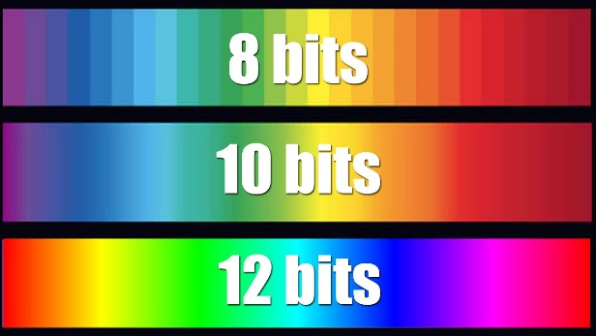

**16-bit color (True Color):** This color depth, also known as 32,768 colors, allows for a wider range of colors than 8-bit color. It is often used for high-quality graphics and video editing. It requires 16 bits per pixel.

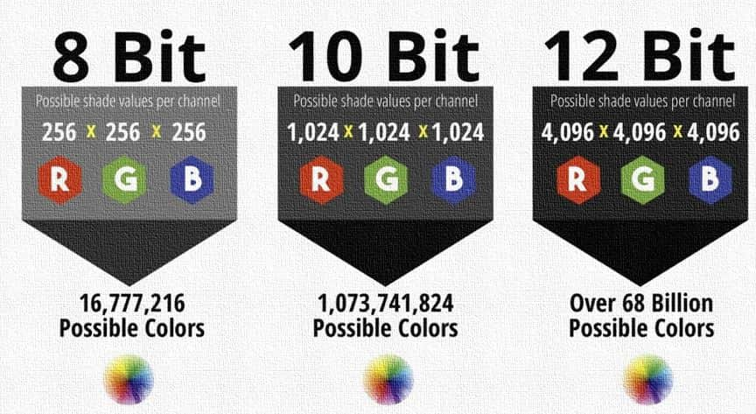

**24-bit color (True Color):** This color depth, also known as full color, is the standard for most modern video displays. It allows for over 16 million unique colors, resulting in very realistic and detailed images. It requires 24 bits per pixel.

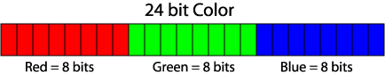

🎨 What Are Color Palettes? (And Why You Should Care)

Let’s rewind to the **90s and early 2000s**...

Imagine your computer screen is like a box of crayons. But — bad news — you only get **256 crayons** at a time, max.

*Now, you want to draw a beautiful image, but that image has* ***thousands or even millions*** *of colors. What do you do?*

💡 **Answer:** You use a **color palette** — a table that says, “Okay, these are the 256 colors I’ll use **for now** to fake or approximate this image.”

A **color palette** is like a menu of available colors your display can use at any given moment. Each item (color index) in that menu points to a specific RGB color.

That’s how older displays worked — because the **graphics memory** was too small to store a unique color value for every single pixel. Instead, it stored **indexes** into a palette — like a shortcut.

🧠 What Happens Under the Hood?

In those older video modes (like **8-bit color**), each pixel didn’t store the full color (like RGB 255, 200, 100). Instead, it just said:

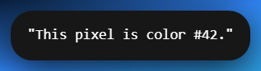

Then the GPU would look up color #42 in the **palette table** to get the actual RGB color.

🧮 How Many Colors Can You Use?

You can use this classic formula:

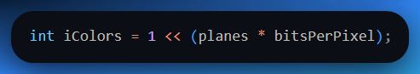

Which means:

* planes: Number of color planes (usually 1)
* bitsPerPixel: How many bits are used per pixel (e.g., 8, 16, 24)

So:

* 8-bit = 1 << 8 = **256 colors**
* 16-bit = 1 << 16 = **65,536 colors**
* 24-bit = 1 << 24 = **~16.7 million colors**

⚠️ But remember, this is **how many colors you *can* represent**, not necessarily how many are visible **at once** on older systems.

📊 Key Device Capabilities

Windows gives you ways to check what kind of color system you're dealing with via GetDeviceCaps().

Here are the key players:

**✅ BITSPIXEL**

* Tells you how many **bits** are used for each pixel (e.g., 8, 16, 24).
* This directly controls **color depth**.

**✅ PLANES**

* Usually just 1 — refers to how many separate memory "layers" of color are supported.
* Mostly historical; in practice, you just multiply PLANES * BITSPIXEL.

**✅ NUMCOLORS**

* Tells you how many **unique colors** your system can use right now.
* But ⚠️ it's **not always reliable**.
  + For 8-bit displays, it gives you something like 236 — the rest are **reserved by Windows**.
  + For anything 16-bit or higher? It might return -1, because those modes don't use color palettes anymore.

🧠 Modern Displays and Why Palettes Are Basically Dead (Kinda)

Today, we use **24-bit or 32-bit true color**. Each pixel stores its own full color (no index). That’s like saying:

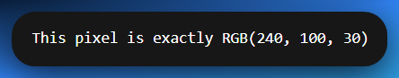

Palettes? Ancient history — unless:

* You're working with **VMs**, **legacy apps**, or **embedded systems**
* You're making **retro-style games** or tools that simulate 8-bit graphics
* You're using the **palette functions in WinAPI** for fun or backward compatibility

🧪 Code Example: Checking Color Depth

Here’s a WinAPI code snippet that tells you how many bits per pixel your screen supports:

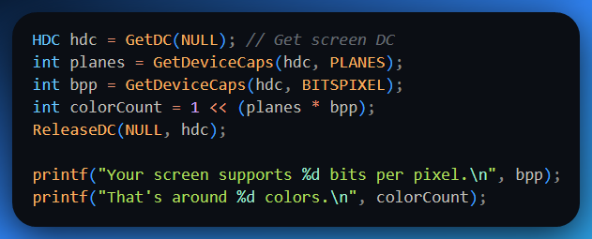

🧑‍🎨 TLDR for Beginners

* A **color palette** is a menu of colors — used heavily in the past when screens could only show **256 colors at a time**.
* Older systems stored color **indexes**, not full RGB values.
* GetDeviceCaps() can help you find out:
  + **BITSPIXEL:** How rich your color support is
  + **PLANES:** Old-school number of color planes (usually 1)
  + **NUMCOLORS:** How many usable colors Windows thinks your display has (not always reliable)
* Modern screens don’t use palettes — they store **true color** per pixel. Palettes still exist in GDI for legacy reasons.

Example Code

Here's an example of how to use the RGB macro and GetNearestColor function:



This code snippet creates a COLORREF value for yellow and then uses GetNearestColor to determine the closest pure non-dithered color representation of yellow on the current video adapter.

In summary, COLORREF values play a crucial role in representing colors in Windows GDI.

They provide a standardized way to specify RGB colors and interact with various GDI functions that deal with color manipulation.

Understanding the structure and usage of COLORREF values is essential for developing graphics-intensive applications using Windows GDI.

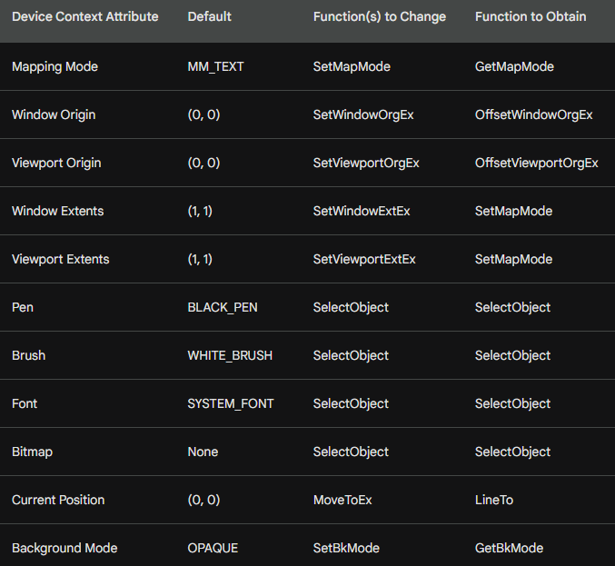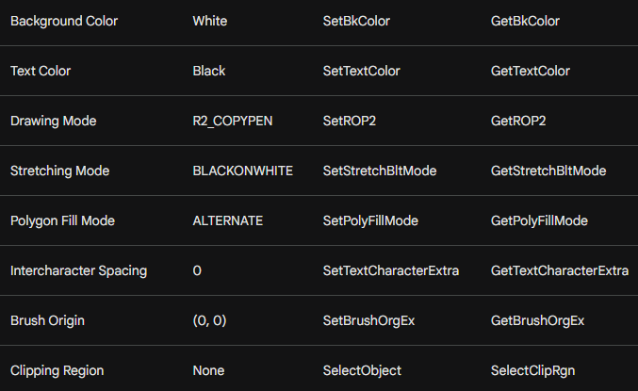

The terms provided above are related to the device context (DC) in Windows GDI (Graphics Device Interface). The DC is a data structure that encapsulates various attributes and settings that control how GDI functions interact with the display.

Mapping Mode

Defines the relationship between logical coordinates and device coordinates.

Logical coordinates are abstract units used to specify positions and dimensions, while device coordinates are physical pixels on the display.

Different mapping modes provide different scaling and translation factors between these two coordinate systems.



Window Origin and Viewport Origin

The window origin and viewport origin are offsets that determine the starting point for mapping logical coordinates to device coordinates.

The window origin affects the entire window, while the viewport origin affects a specific rectangular region within the window.

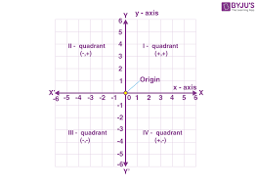

Window Extents and Viewport Extents

Window extents and viewport extents define the size of the logical coordinate space and the visible portion of the window, respectively.

Window extents specify the width and height of the logical coordinate space, while viewport extents specify the width and height of the visible area within the window.

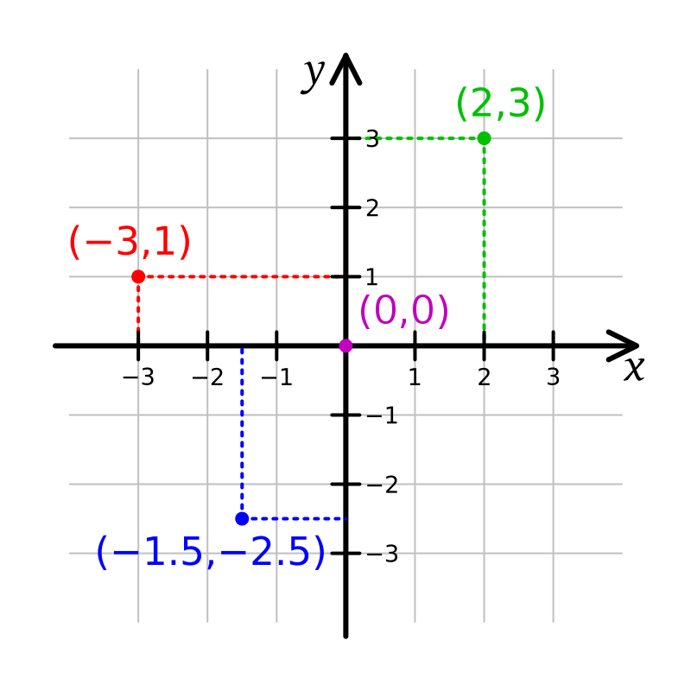

Pen and Brush

A pen is an object that defines the style and attributes of lines drawn using GDI functions. It specifies properties like line width, color, and pattern.

A brush is an object that defines the style and attributes of filled areas using GDI functions. It specifies properties like fill color, pattern, and transparency.

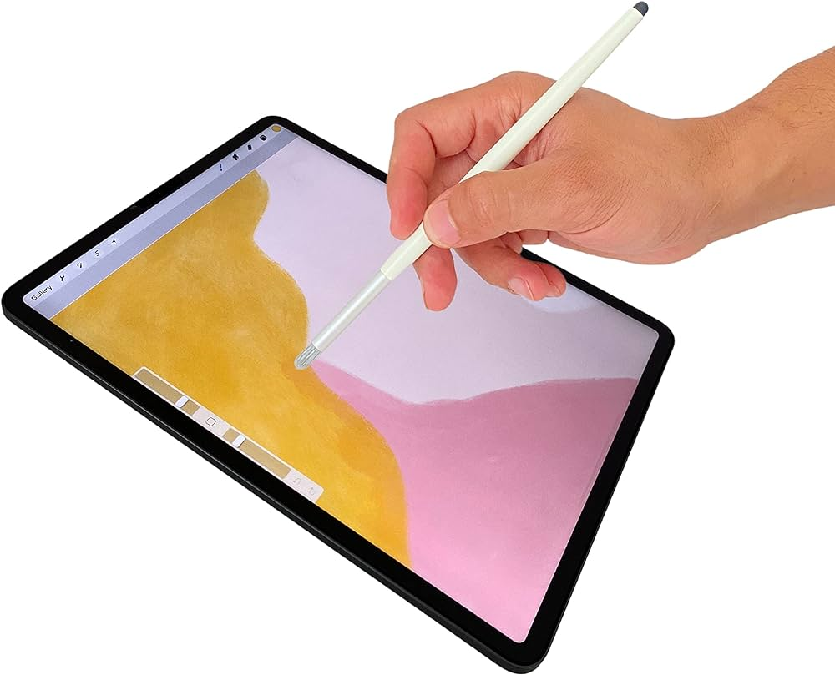

Font

A font defines the appearance of text characters. It specifies properties like typeface, size, weight, and style.

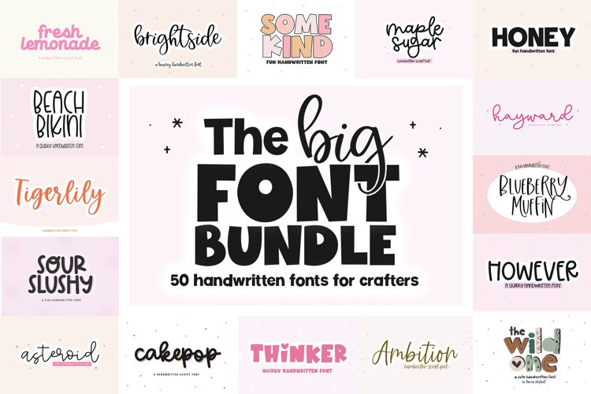

Bitmap

A bitmap is a rectangular image represented as a grid of pixels. It can be displayed, copied, or manipulated using GDI functions.

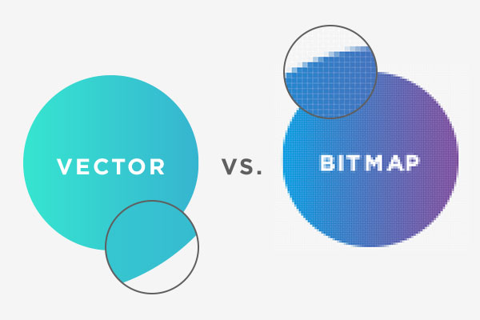

Current Position

The current position is the point where the next GDI drawing operation will begin. It is typically set using functions like MoveToEx and updated as drawing operations are performed.

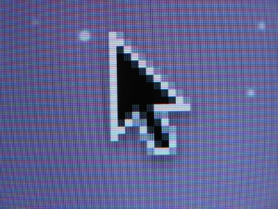

Background Mode

Background mode determines how the background color is handled when drawing shapes and text. OPAQUE mode fills the background with the specified color, while TRANSPARENT mode allows the underlying background to show through.

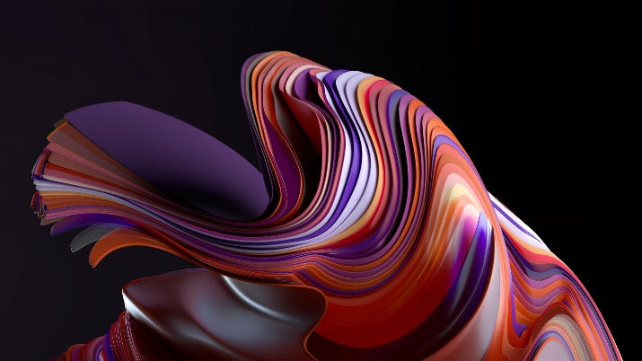

Background Color and Text Color

Background color specifies the color used to fill the background of the drawing area, while text color specifies the color of text drawn using GDI functions.

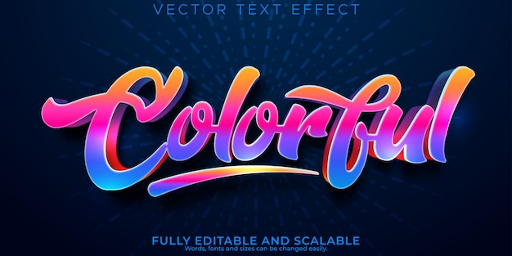

Drawing Mode

Drawing mode defines how source pixels are combined with destination pixels when drawing shapes and text. It determines how colors are composited and blended.

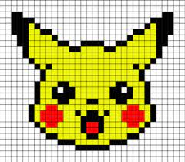

Stretching Mode

Stretching mode determines how an image is scaled when displayed using the StretchBlt function. It specifies how to handle color interpolation and maintain aspect ratio.

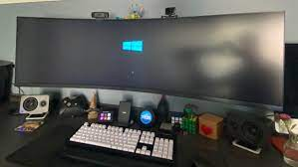

Polygon Fill Mode

Polygon fill mode specifies how the interior of a polygon is filled when drawn using the PolyFill function. It determines how the filling algorithm handles edges and intersections.

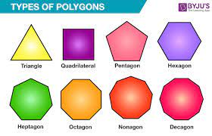

Intercharacter Spacing

Intercharacter spacing adjusts the horizontal spacing between characters when drawing text using GDI functions. It can be used to control text density and readability.

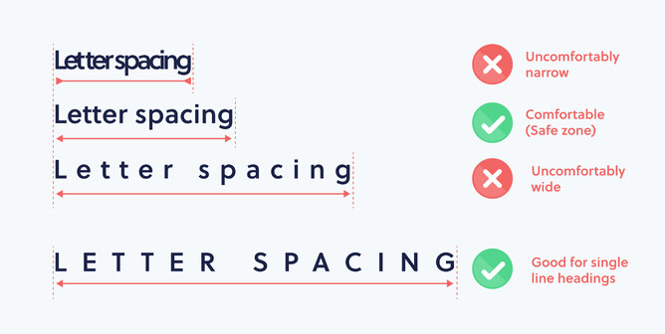

Brush Origin

Brush origin specifies the offset applied to the pattern of a brush when drawing filled shapes. It allows for tiling or repositioning the brush pattern.

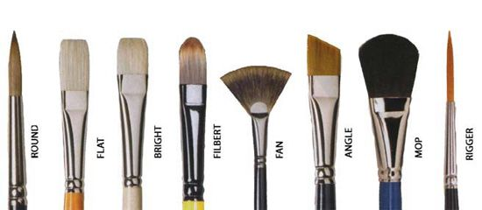

Clipping Region

Clipping region defines a rectangular area that restricts the drawing area. GDI functions only draw within the specified clipping region, preventing drawing outside the defined boundaries.

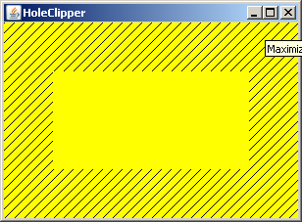

These device context attributes are crucial for controlling the appearance and behavior of graphics operations in Windows GDI.

Understanding their purpose and usage is essential for developing graphics-intensive applications using Windows GDI.

SAVING DEVICE CONTEXT IN WINGDI

Default Device Context Behavior

By default, when you obtain a device context (DC) using GetDC or BeginPaint, Windows provides a temporary DC with default values for all its attributes.

Any modifications you make to these attributes are lost when you release the DC with ReleaseDC or EndPaint.

Saving Device Context Attributes

If your application requires non-default DC attributes, you'll need to initialize the DC's attributes every time you obtain a new DC handle.

This can be cumbersome and inefficient, especially if you frequently need to use specific attribute settings.

CS_OWNDC Window Class Style

To overcome this limitation, you can utilize the CS_OWNDC flag when registering your window class.

This flag instructs Windows to create a private DC for each window instance, ensuring that the DC persists even after the window is destroyed.

Benefits of CS_OWNDC

Using CS_OWNDC offers several advantages:

Attribute Persistence: Changes made to the DC's attributes remain in effect until explicitly modified, eliminating the need to reinitialize the DC's attributes with each WM_PAINT message.

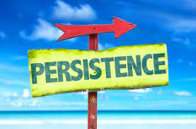

Performance Optimization: By avoiding repeated DC initialization, you reduce the overhead associated with creating and destroying temporary DCs, improving application performance.

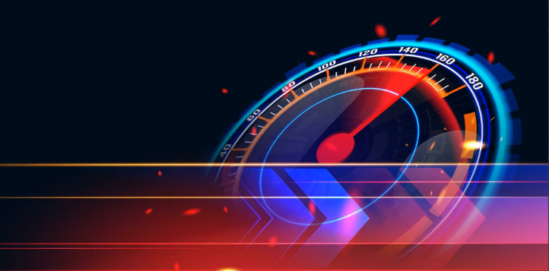

Initializing the Device Context

When using CS_OWNDC, you only need to initialize the DC's attributes once, typically in response to the WM_CREATE message:

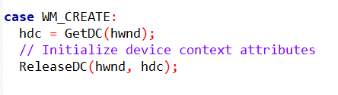

Once initialized, the DC's attributes remain valid until you explicitly change them. This approach is more efficient and convenient for applications that require consistent DC configurations.

Device Context Persistence with CS_OWNDC

The CS_OWNDC window class style instructs Windows to create a private device context (DC) for each window instance.

This private DC persists even after the window is destroyed, unlike the temporary DCs obtained with GetDC or BeginPaint.

Using CS_OWNDC eliminates the need to reinitialize DC attributes with every WM_PAINT message, improving performance for graphics-intensive applications.

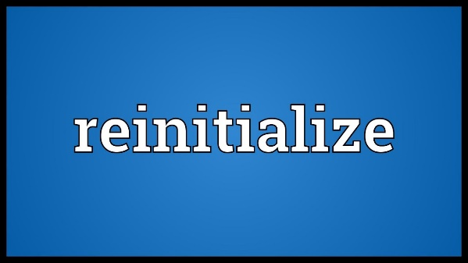

Saving and Restoring Device Context State

The SaveDC and RestoreDC functions allow you to save and restore the state of a device context.

This is useful when you need to temporarily modify the DC's attributes, perform some drawing operations, and then restore the DC to its original state.

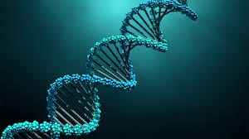

Saving Multiple States

You can call SaveDC multiple times before calling RestoreDC.

Each SaveDC call creates a new state on the DC stack.

When you call RestoreDC, it restores the DC to the state at the top of the stack.



Common Usage Pattern

The most common usage pattern for SaveDC and RestoreDC involves saving the DC state before making changes and then restoring the state after performing the desired operations.

This ensures that the DC is restored to its original state regardless of how many times SaveDC is called.

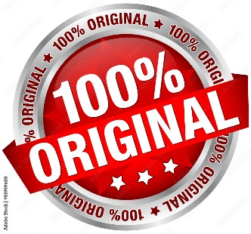

Restoring to the Most Recent State

Calling RestoreDC with -1 restores the DC to the state saved by the most recent SaveDC call. This is equivalent to popping the top state from the stack.

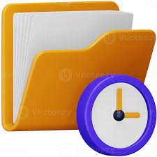

CS_OWNDC and Device Context Handles

Even if you use CS_OWNDC, you should still release the device context handle before exiting the window procedure.

This ensures that all resources associated with the DC are properly cleaned up.



Conclusion

Saving device contexts using the CS_OWNDC flag can significantly simplify and optimize your GDI programming by eliminating the need for repeated DC initialization and allowing you to maintain persistent DC configurations.

This approach is particularly beneficial for applications that frequently use non-default DC attributes.

Saving and restoring device context state is a valuable technique for manipulating device context attributes and maintaining the desired graphical environment within your Windows GDI applications.

Understanding the usage of SaveDC and RestoreDC allows you to effectively control the appearance and behavior of your graphics operations.

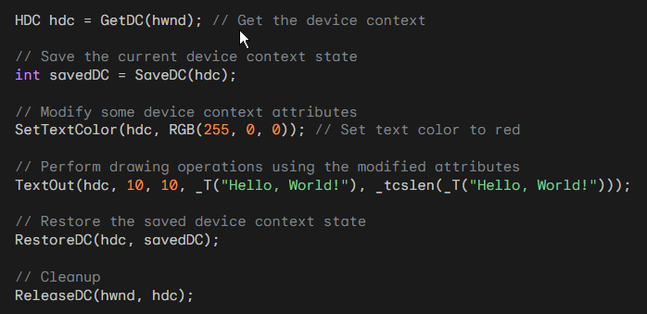

In this example, the **current device context state** is saved before modifying the text color and drawing a text string.

Then, the saved state is restored before releasing the device context. This ensures that the device context's attributes are reverted to their original values.

Continued in chapter 5 part 2…